**LABORATORY REPORT**

**CHALLENGING TASK**

**AWS SOLUTION ARCHITECT**

**CSE3016**

**BL2025260100772**

**Submitted by**

**NAME: Himanshu**

**REG. NO.: 22BCE10118**

**BTech – BACHELOR OF TECHNOLOGY**



**Submitted to**

**Mr. Satyabrata Nath**

**Teaching Fellow**

**SCHOOL OF COMPUTER SCIENCE AND ENGINEERING (SCOPE)**

**VIT BHOPAL UNIVERSITY**

**July-August 2025**

**Q1. Set up CloudWatch monitoring for AWS resources, create custom metrics and alarms, analyze logs, and troubleshoot performance issues using CloudWatch.**

**Ans.**

With the help of below mentioned steps you can complete the required task :

1. Log into aws management console .

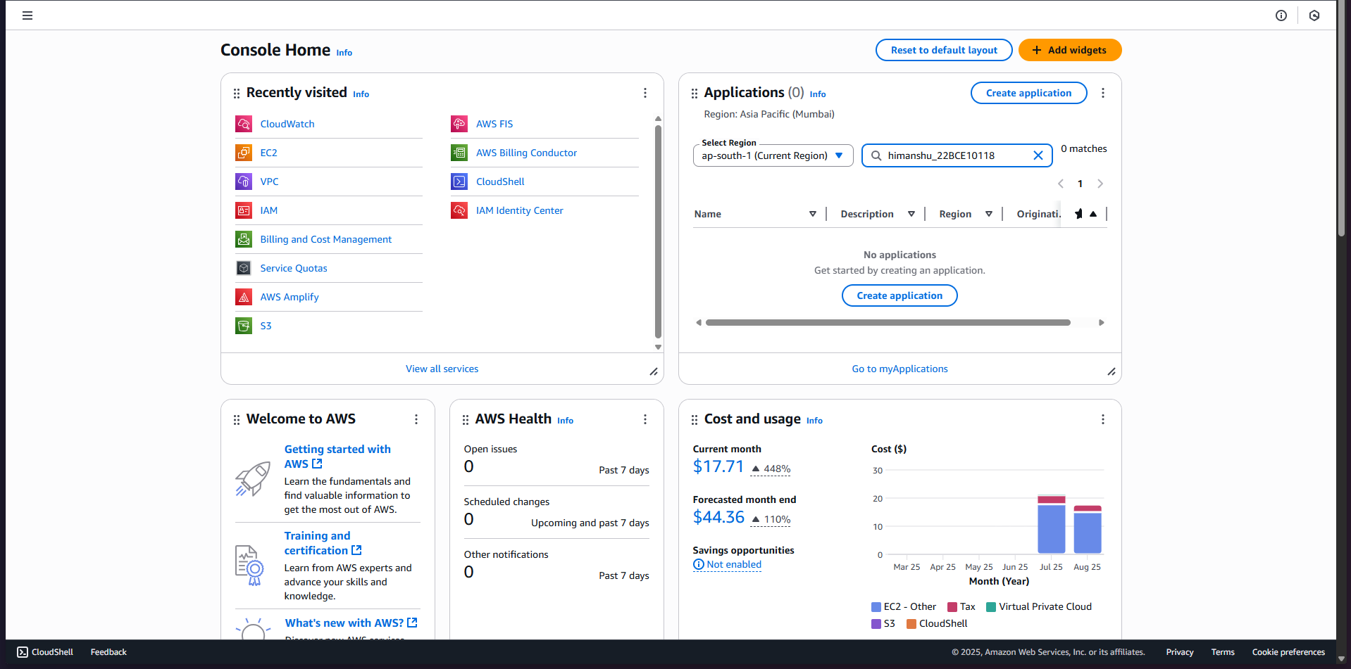

1. Once logged in, go to the EC2 service from the AWS Console

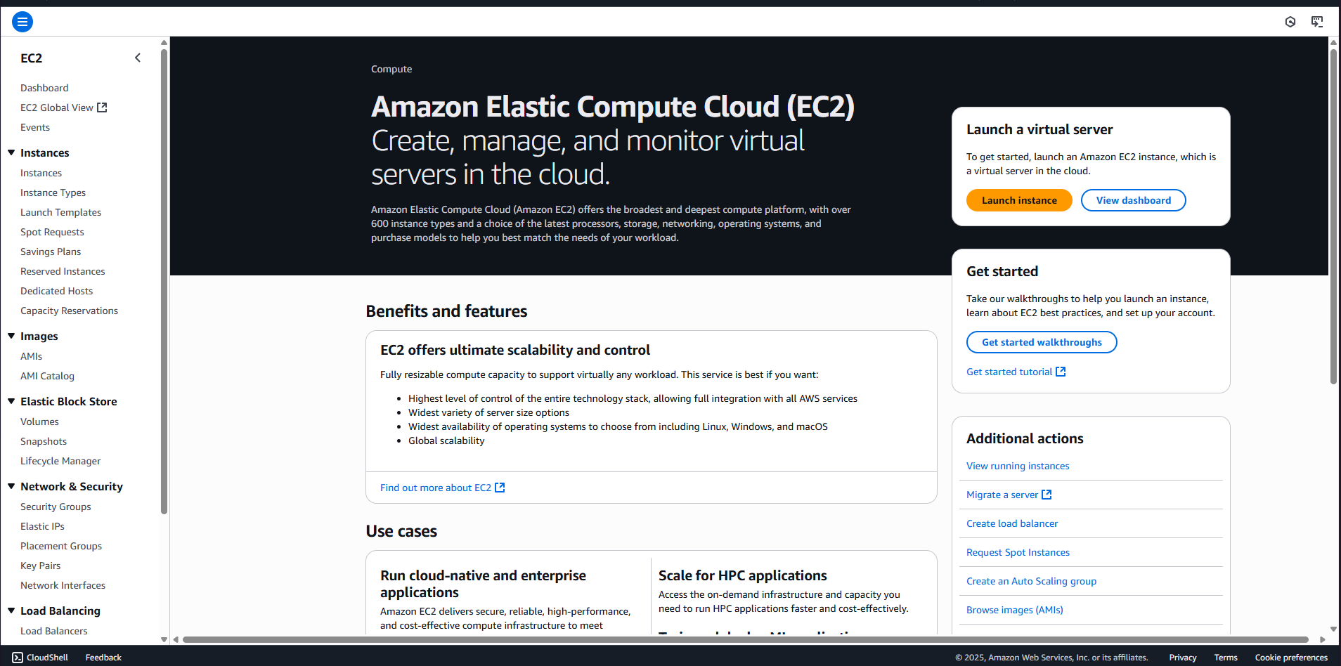

1. Launch a new EC2 instance or select an existing one to monitor. In this case lets launch a new instance . Click on launch instance .

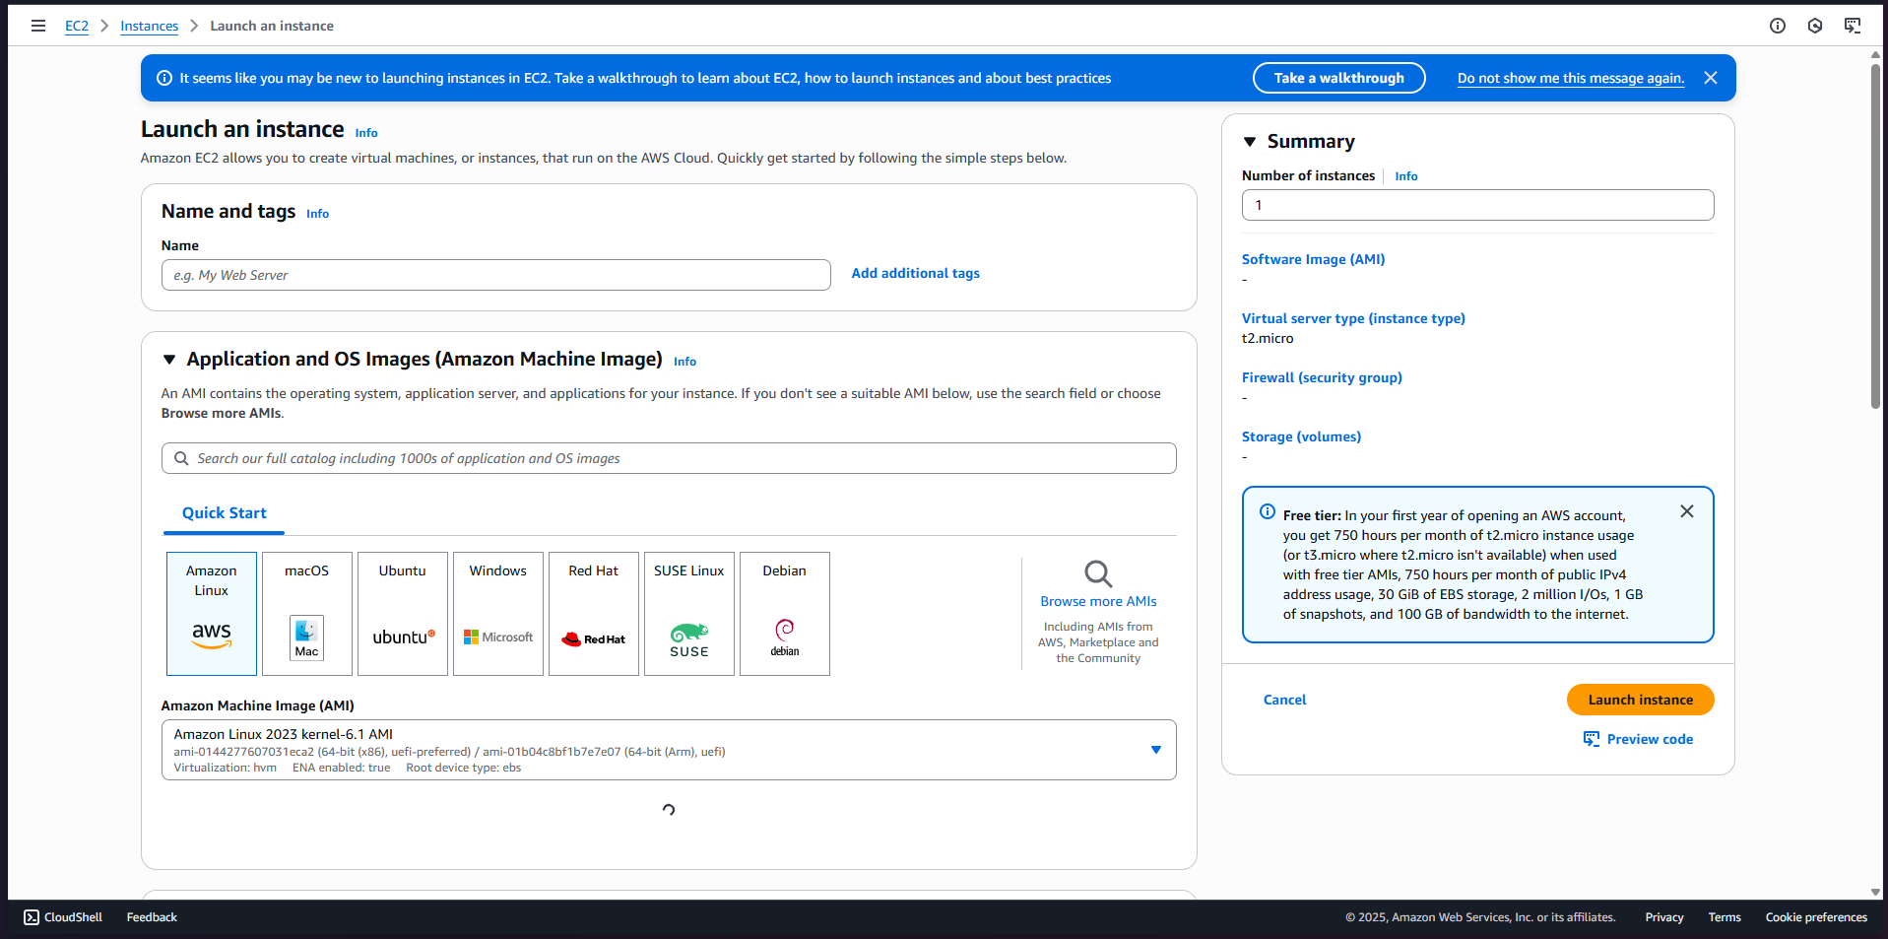

1. Fill up the required details .

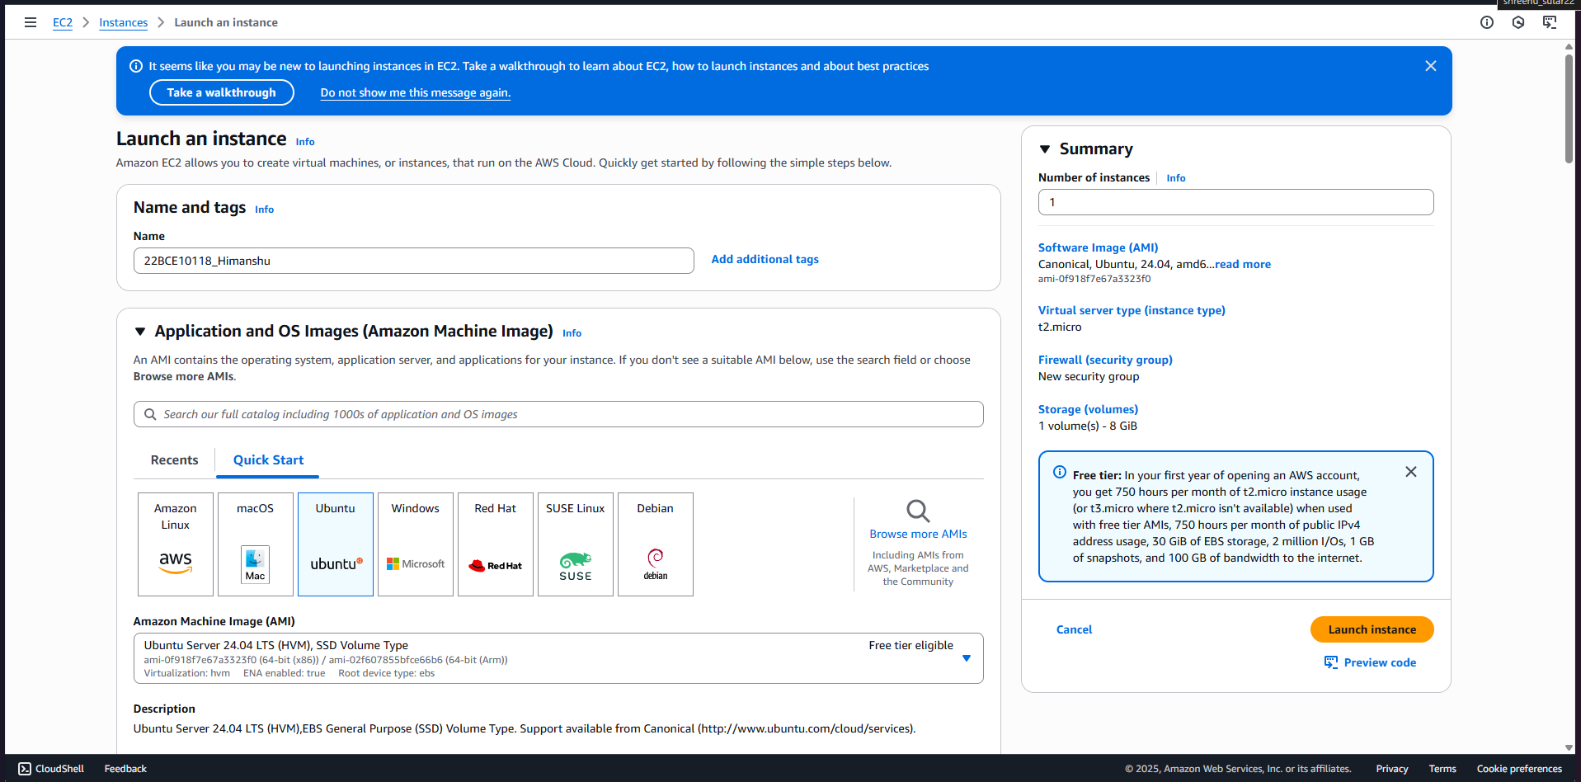

1. Make sure to enable "Detailed monitoring" when configuring the instance in the Monitoring section for better CloudWatch data granularity.

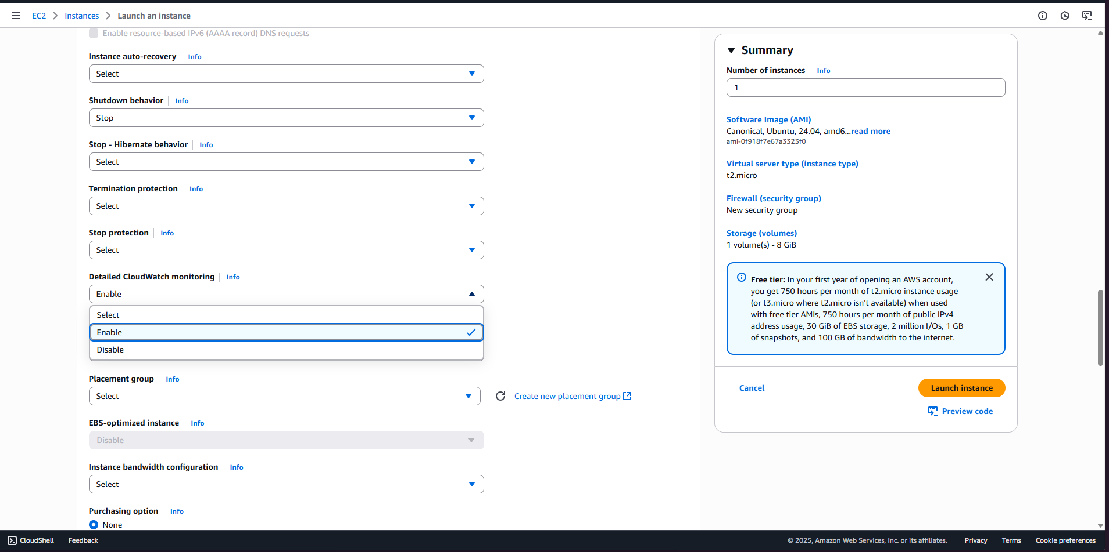

1. Click on launch instance and instance is successfully created and running .

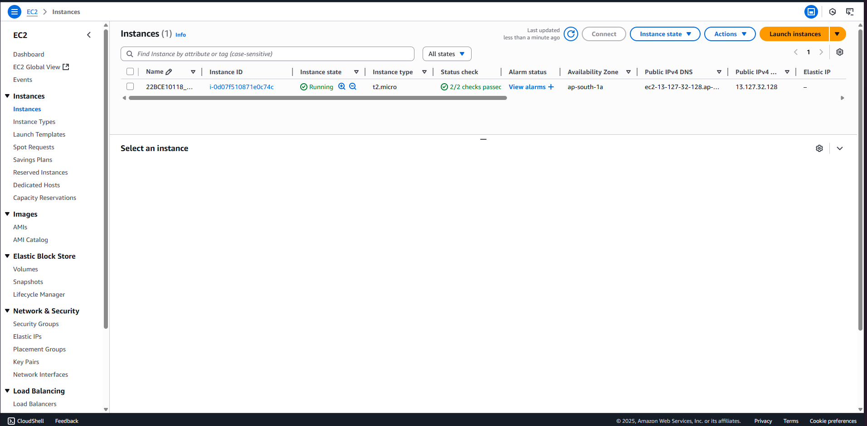

1. Now , In the AWS Console search bar, open the CloudWatch service by typing "CloudWatch" and selecting it.

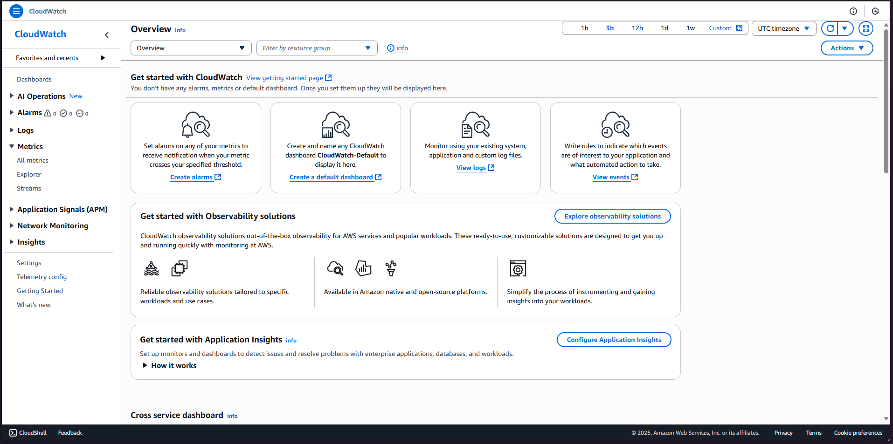

1. In the CloudWatch dashboard, click "Metrics" on the left menu , then go to all metrices .

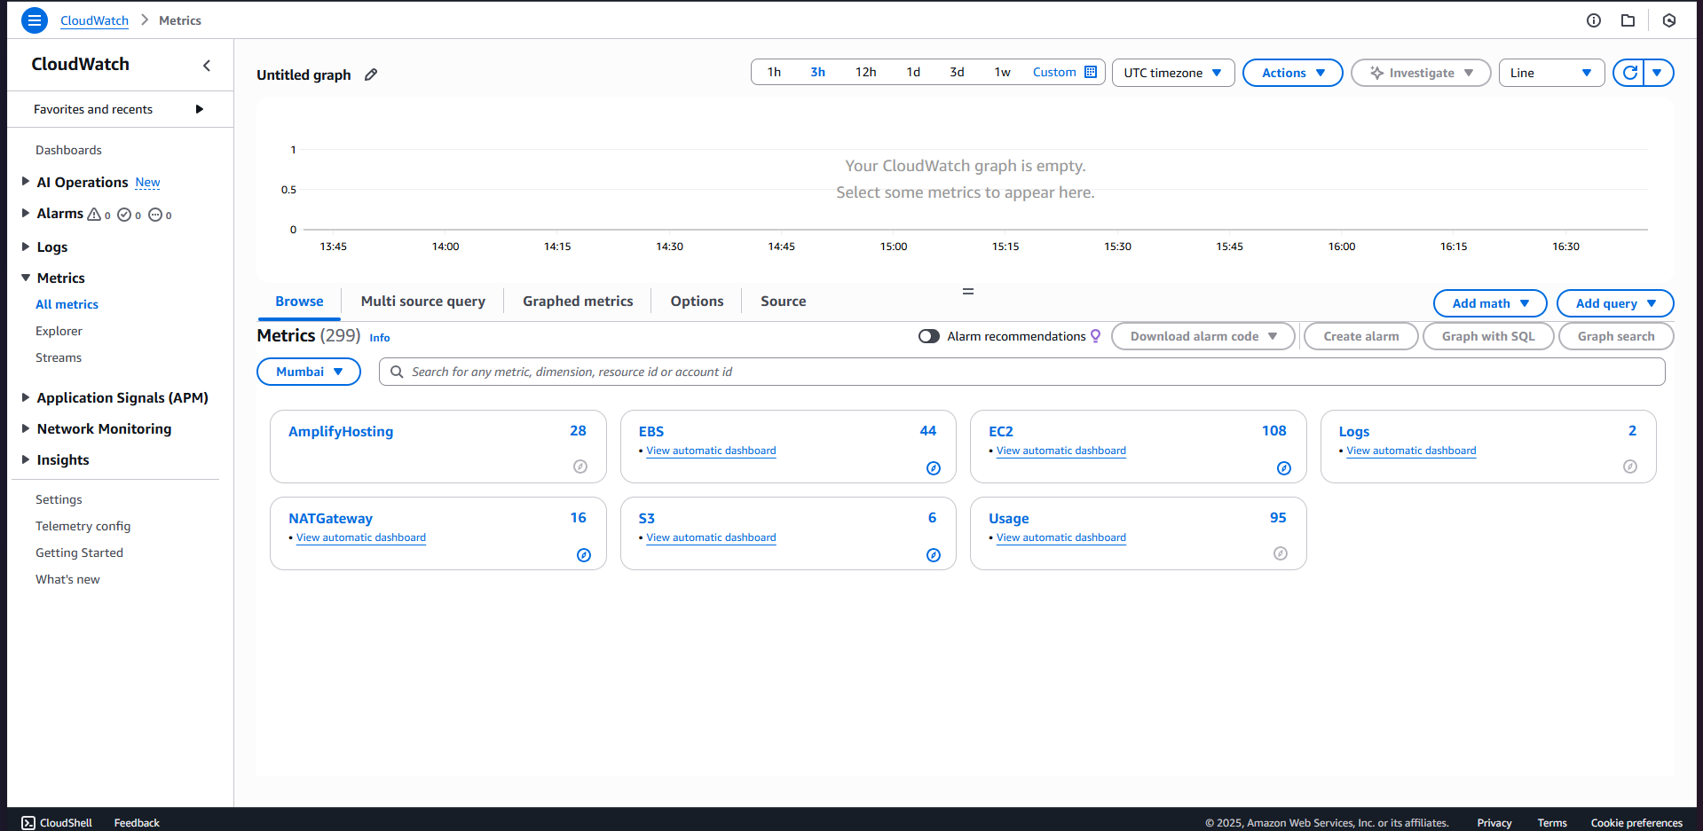

1. Now to monitor created instance , click on ec2 then pre-instance metrices . you will be viewing all available instances to monitor , so now click on 22BCE10118_himanshu (anyone or more) , which we created just now .

You are seeing the activity of selected metrices .

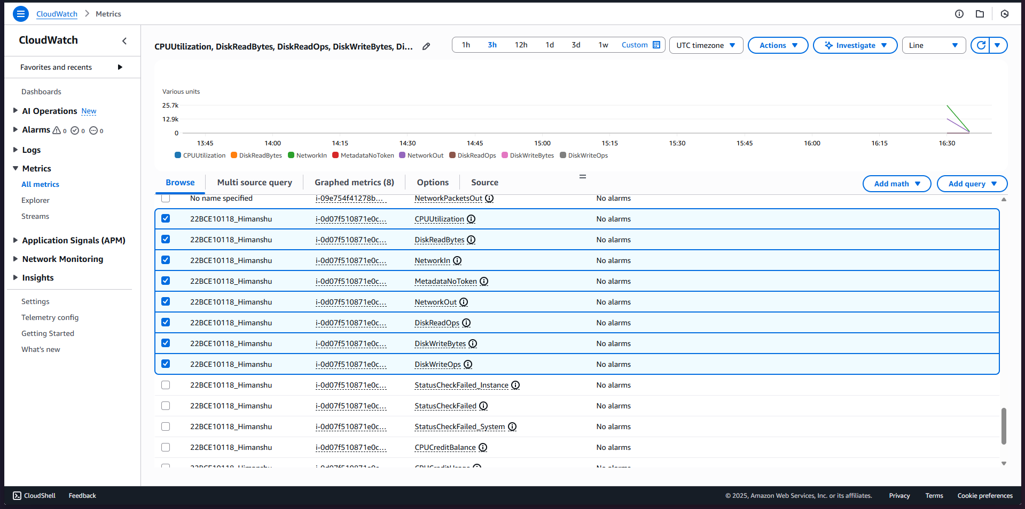

1. Open the AWS CLI or AWS CloudShell from the AWS Console for running commands.

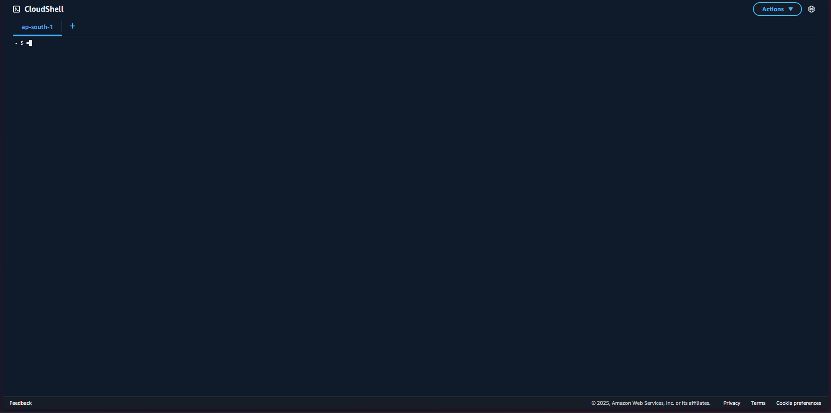

1. Use the command below to send a custom metric to CloudWatch:

aws cloudwatch put-metric-data --metric-name CustomMetric_22BCE10118_Himanshu --namespace CustomMetrics --value 1

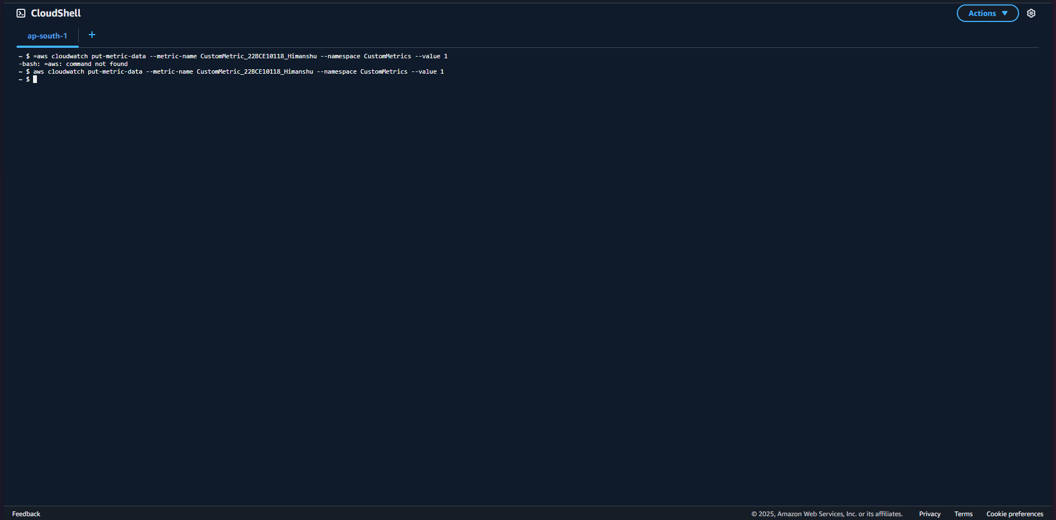

1. Return to CloudWatch console, refresh the Metrics page, and look for your custom namespace "CustomMetrics".

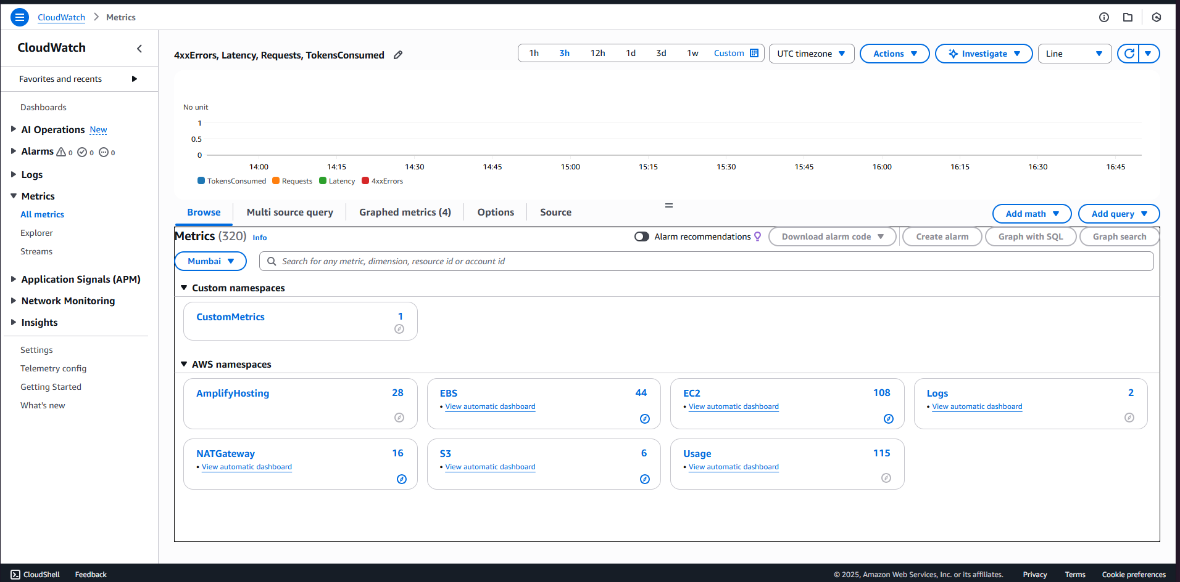

1. Locate the custom metric you created called CustomMetric_registrationno_name.

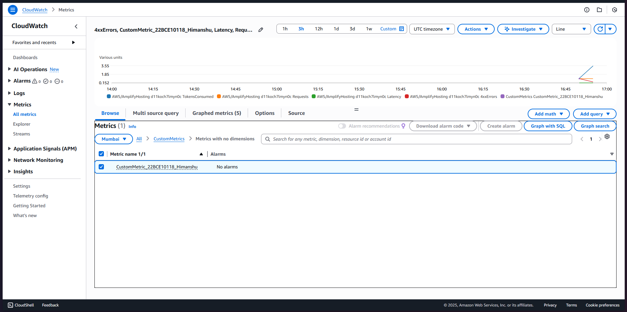

1. Now monitoring done and time to set up alarm . Click "Alarms" in the CloudWatch menu and then click "Create Alarm".

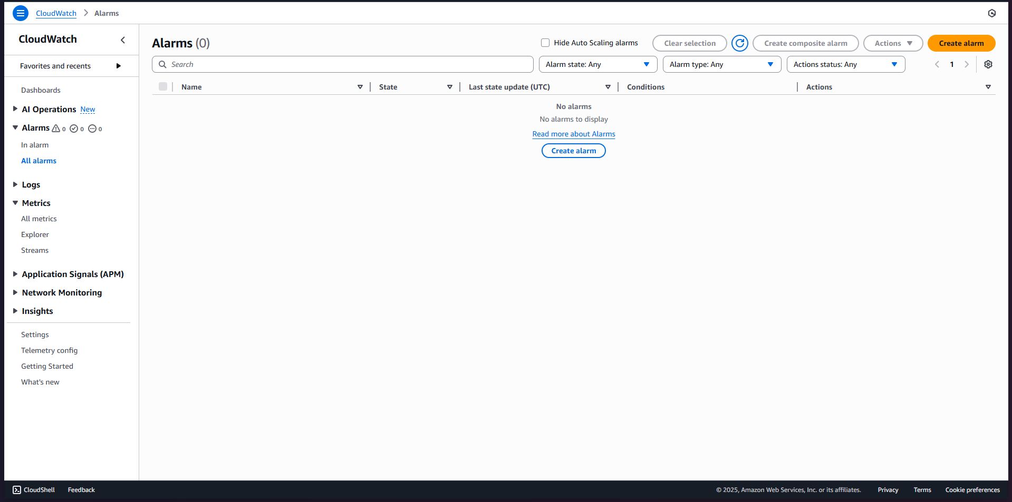

1. Select your custom metric CustomMetric_registrationno_name from the "CustomMetrics" namespace.

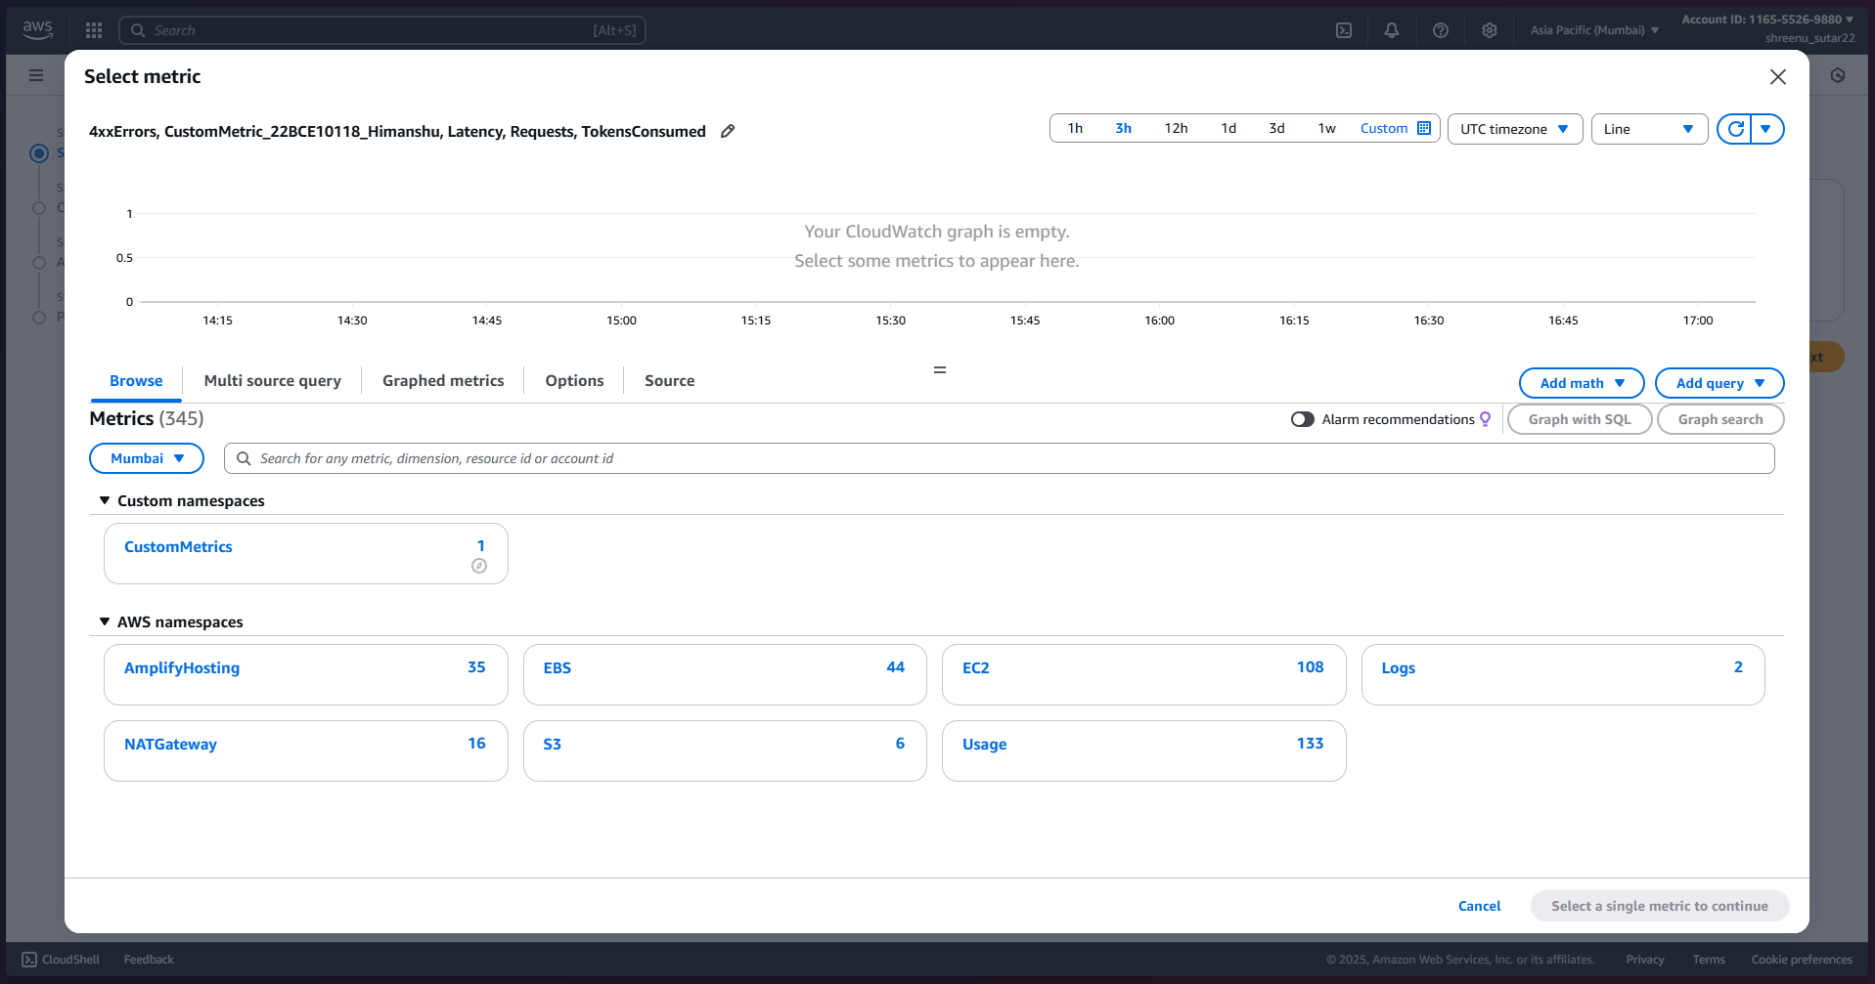

1. Set the threshold for your alarm, for example, set it to alarm when the metric value is greater than .

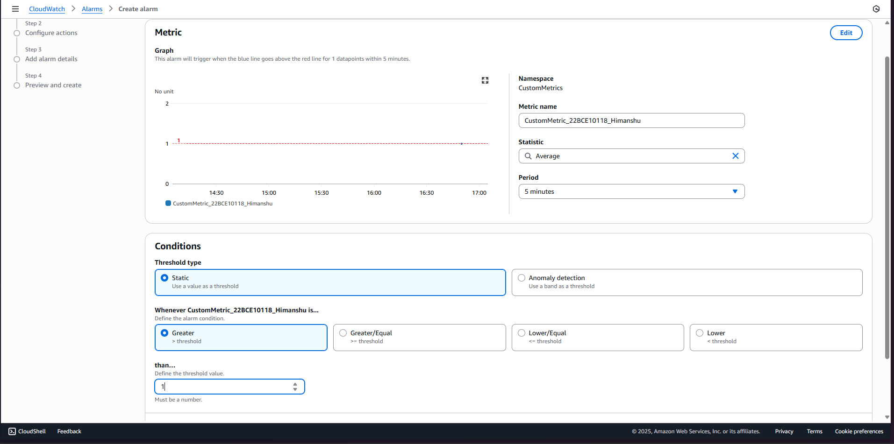

1. Configure alarm actions, such as sending notifications via SNS or automatically taking recovery actions.

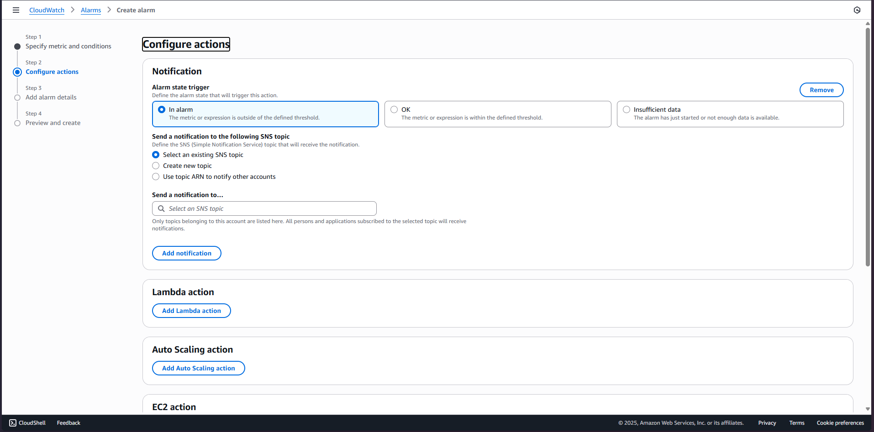

1. Name the alarm and finally create it .

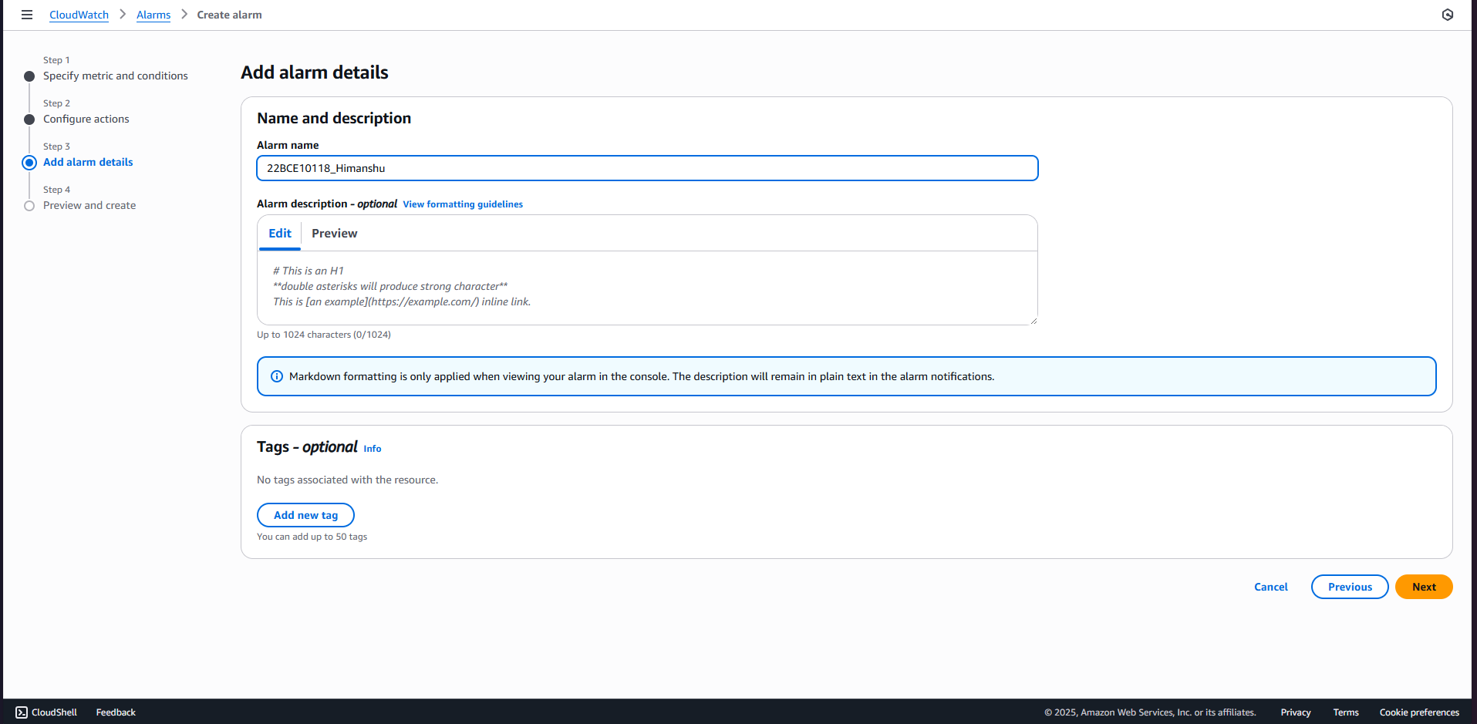

1. Alarm successfully created.

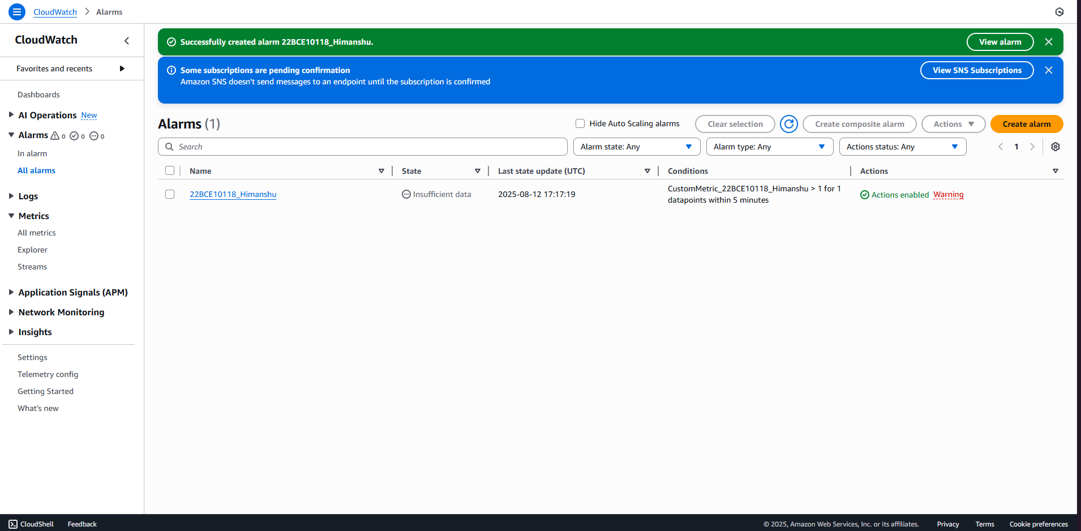

1. Now on the left hand side go on log groups and click on create log group .

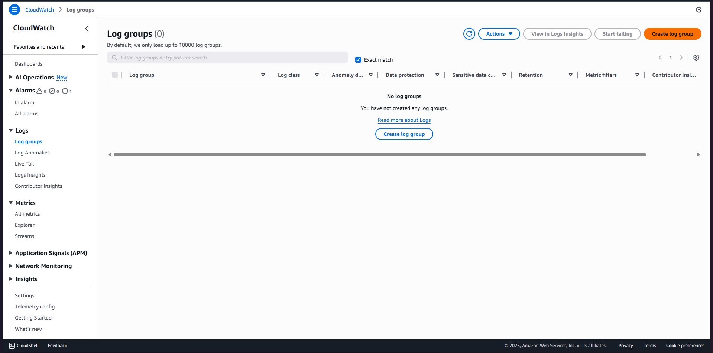

1. Fill in the details and click on create .

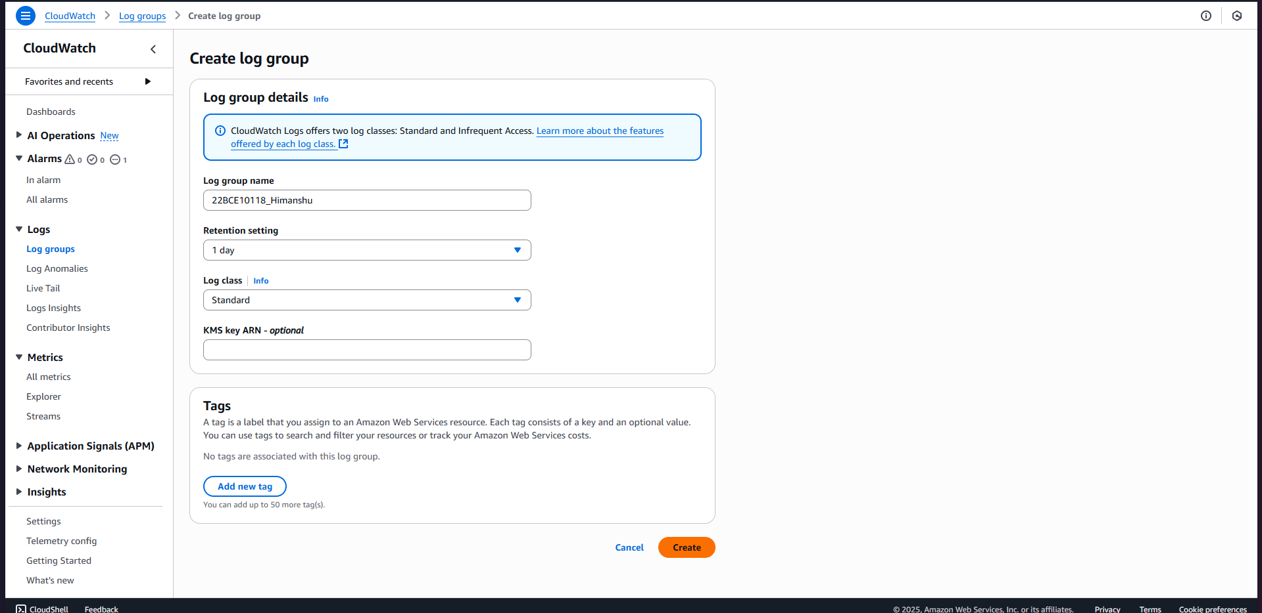

1. Log group successfully created .

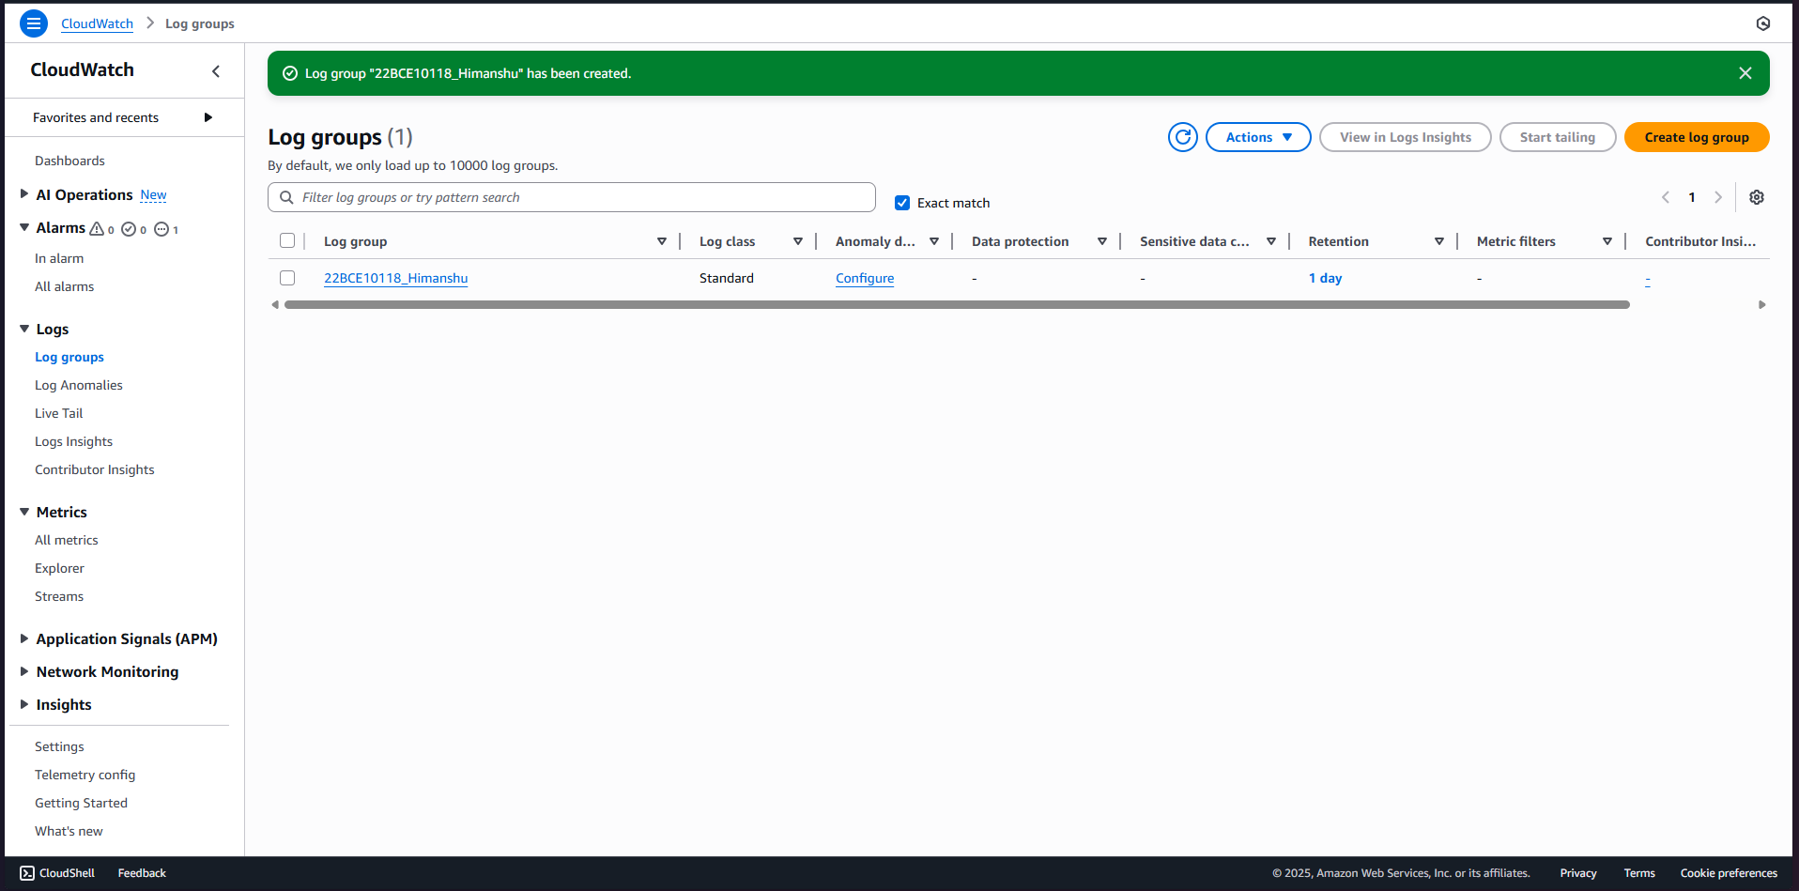

1. In the CloudWatch console, open the Logs section and select your /22BCE10118_Himanshu.

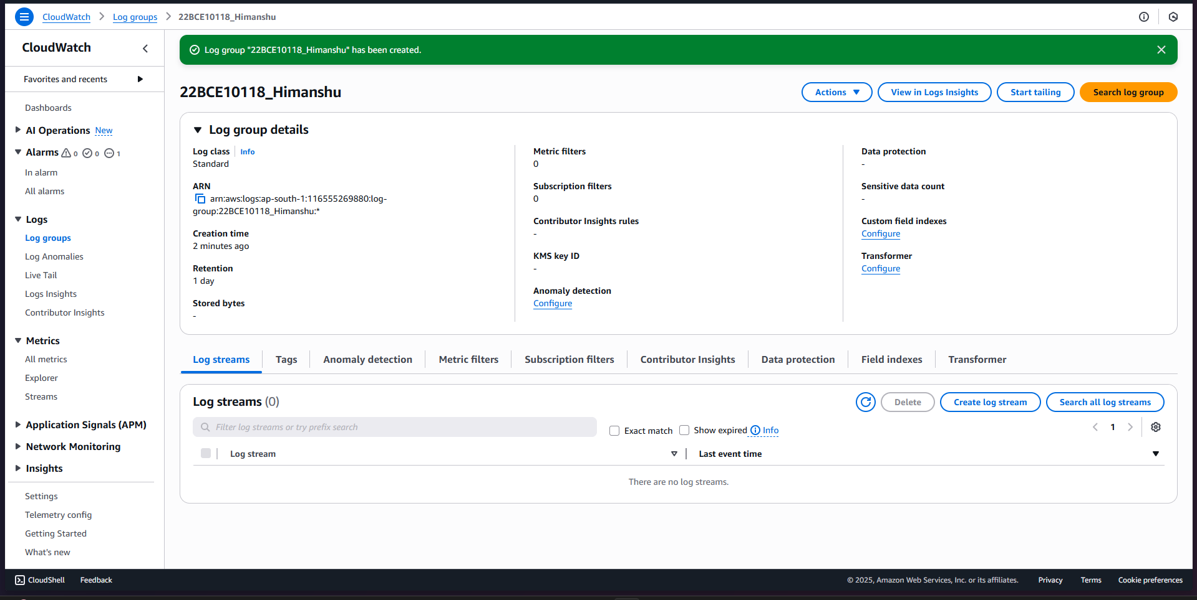

1. Use log insights to check for any performance error or anomalies .

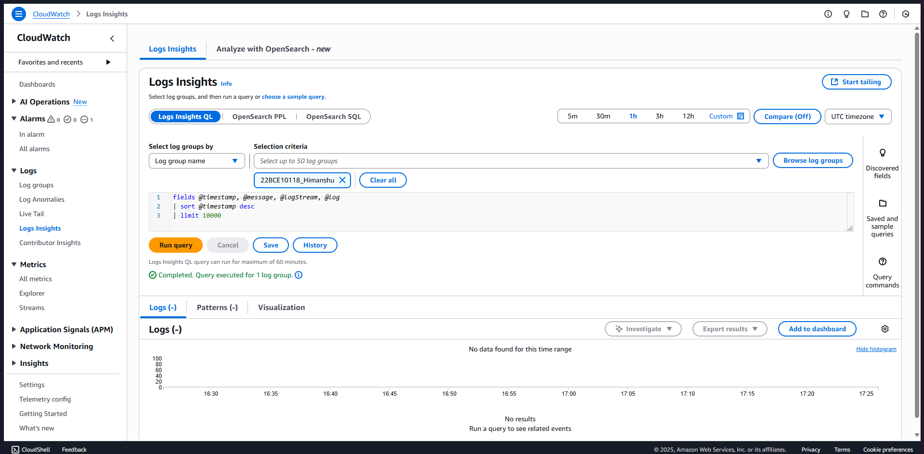

1. Now , In CloudWatch, click "Dashboards" in the menu and create a new dashboard named 22BCE10118_Himanshu_dashboard

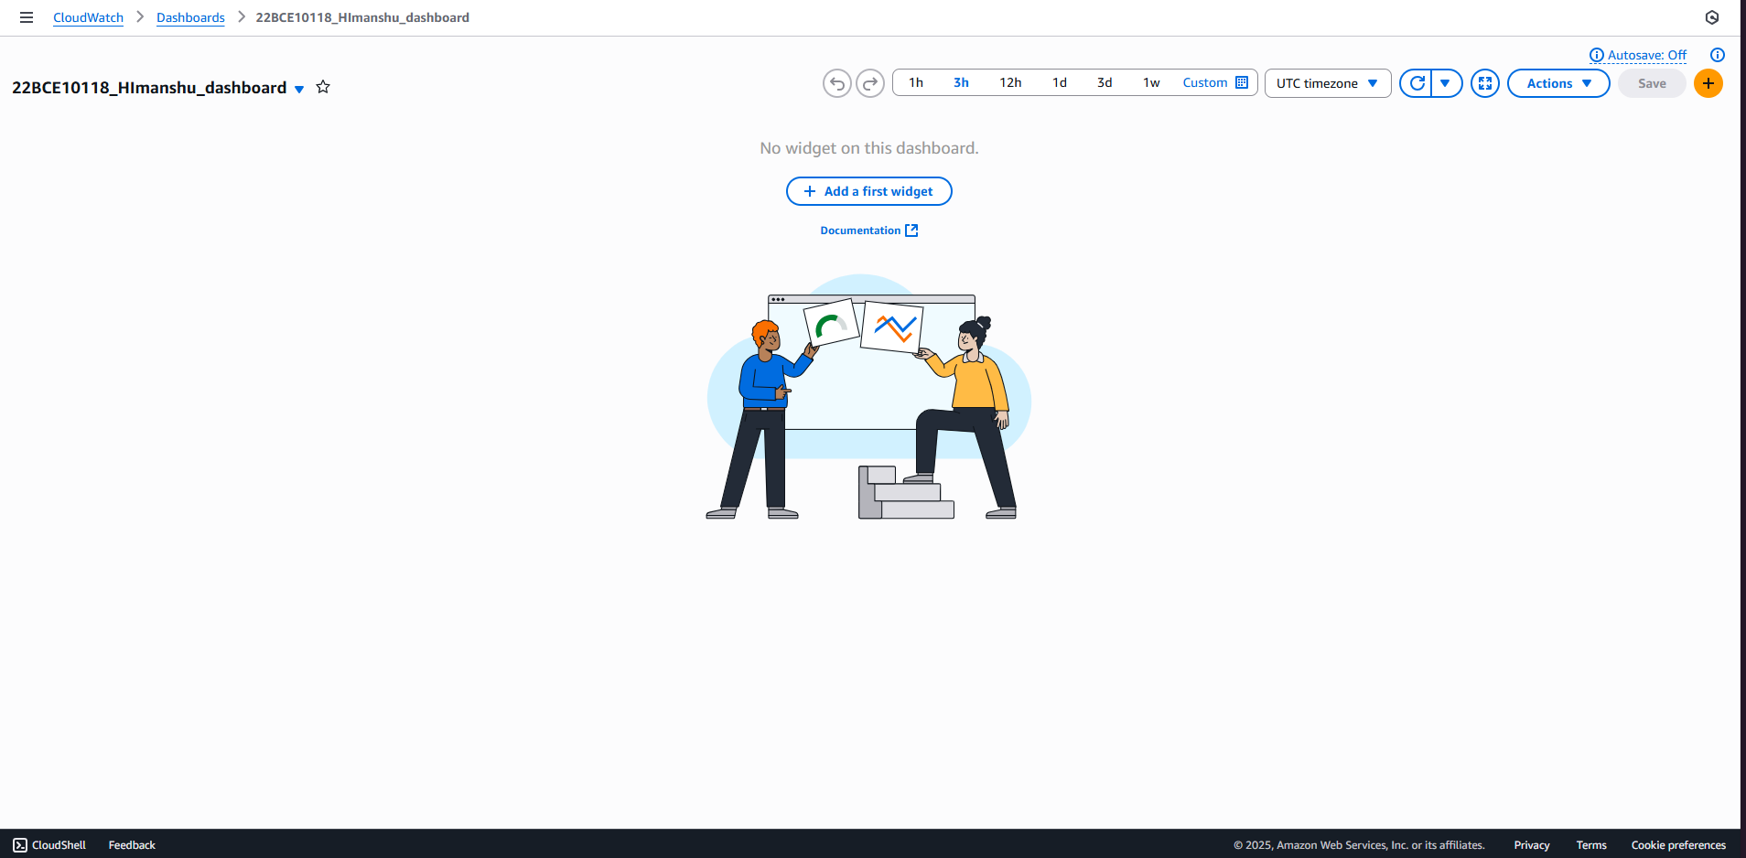

1. Add widgets to the dashboard to visualize your EC2 instance default metrics, custom metrics, and logs insights queries.

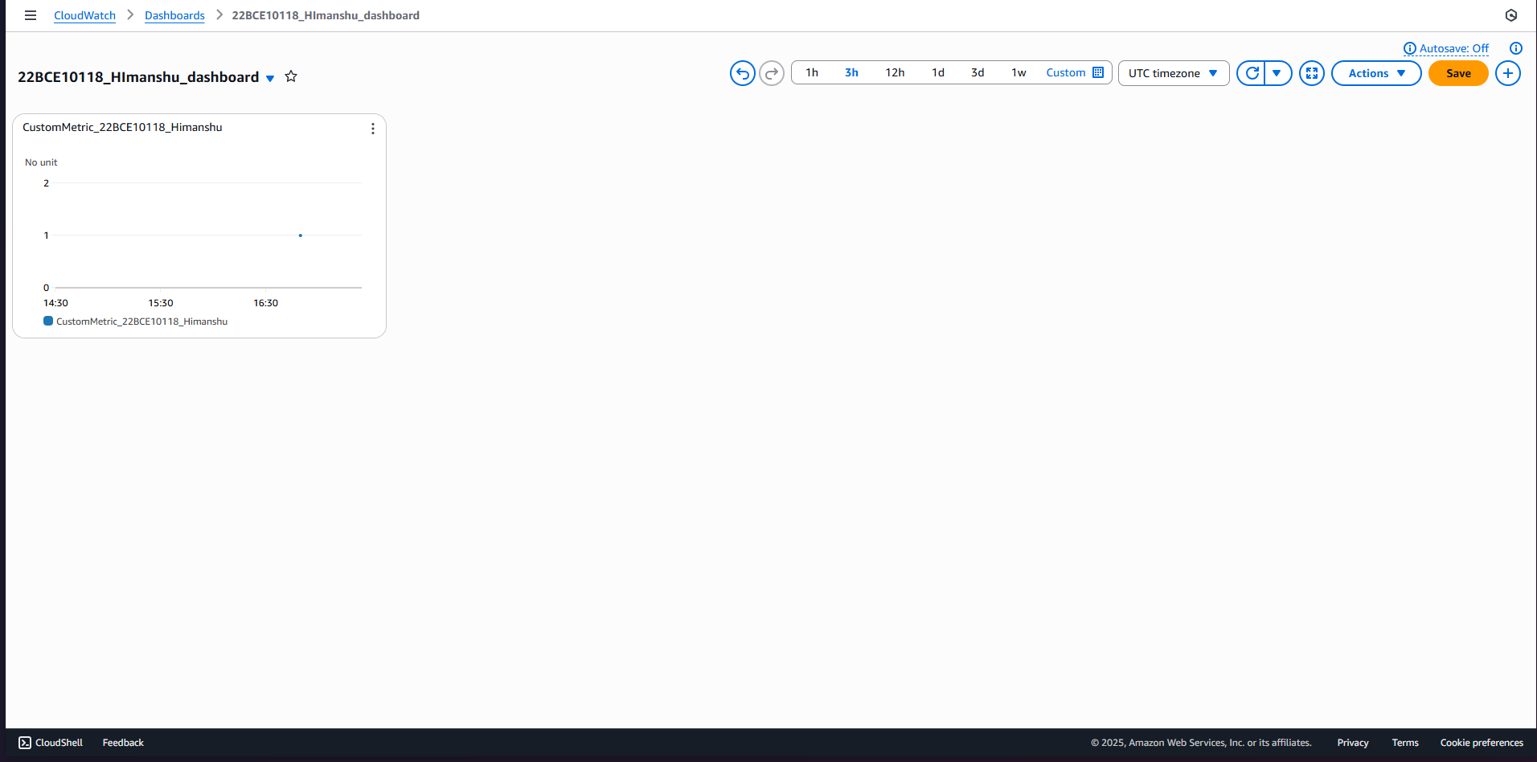

1. Use these visualizations to troubleshoot performance issues by correlating alarms, logs, and metrics data.

**Q2. Implement Multi-Factor Authentication (MFA) for AWS Accounts and Enforce MFA Usage via IAM Policies, Validate through CloudTrail Logs, and Configure Optional Login Alerts via SNS.**

**Ans.**

**With the help of below mentioned steps you can complete the required task :**

1. Log in to the AWS Management Console and open the IAM service.

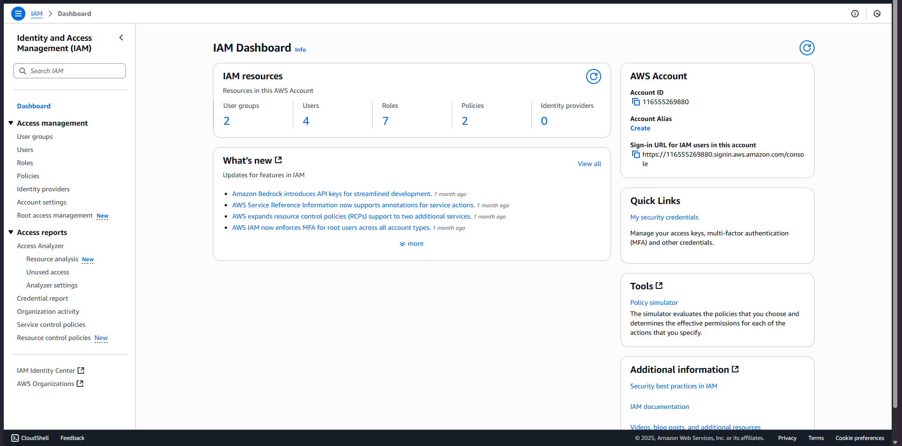

1. Select the user for whom you want to enable MFA or create a new IAM user.

(selecting already available user)

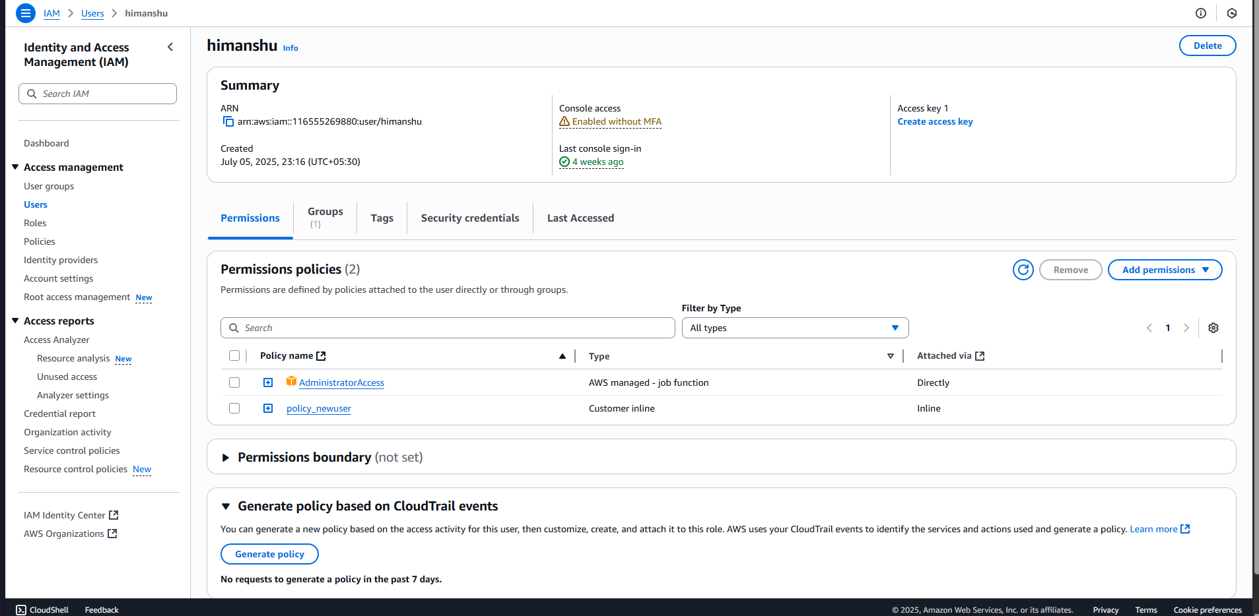

1. In the user’s Security Credentials tab, click “Assign” under Multi-Factor Authentication (MFA).

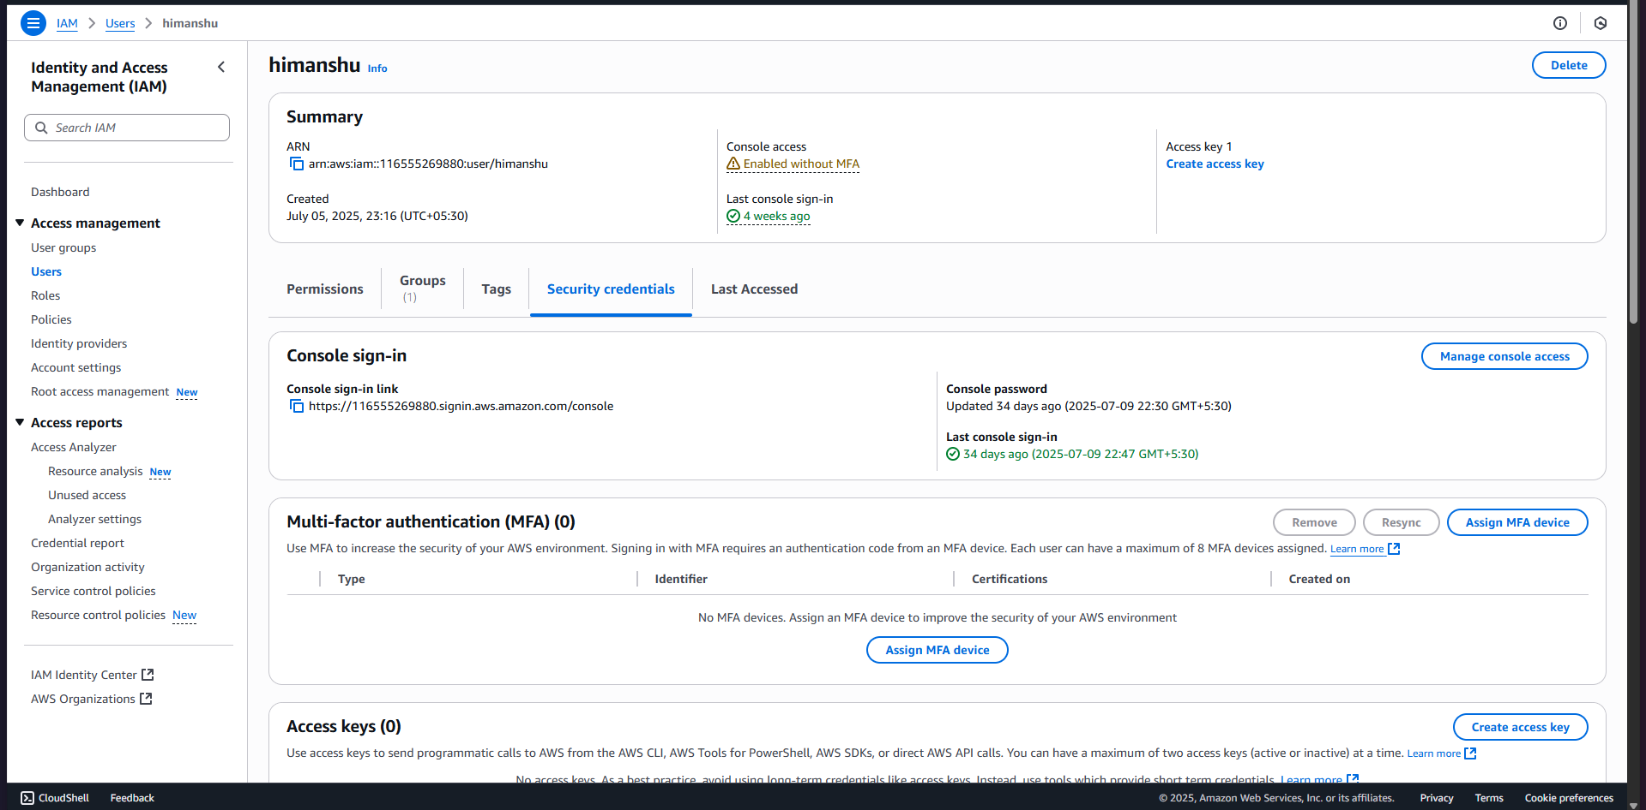

1. Activate MFA by selecting the type (virtual authenticator app like Google Authenticator) and following the setup instructions.

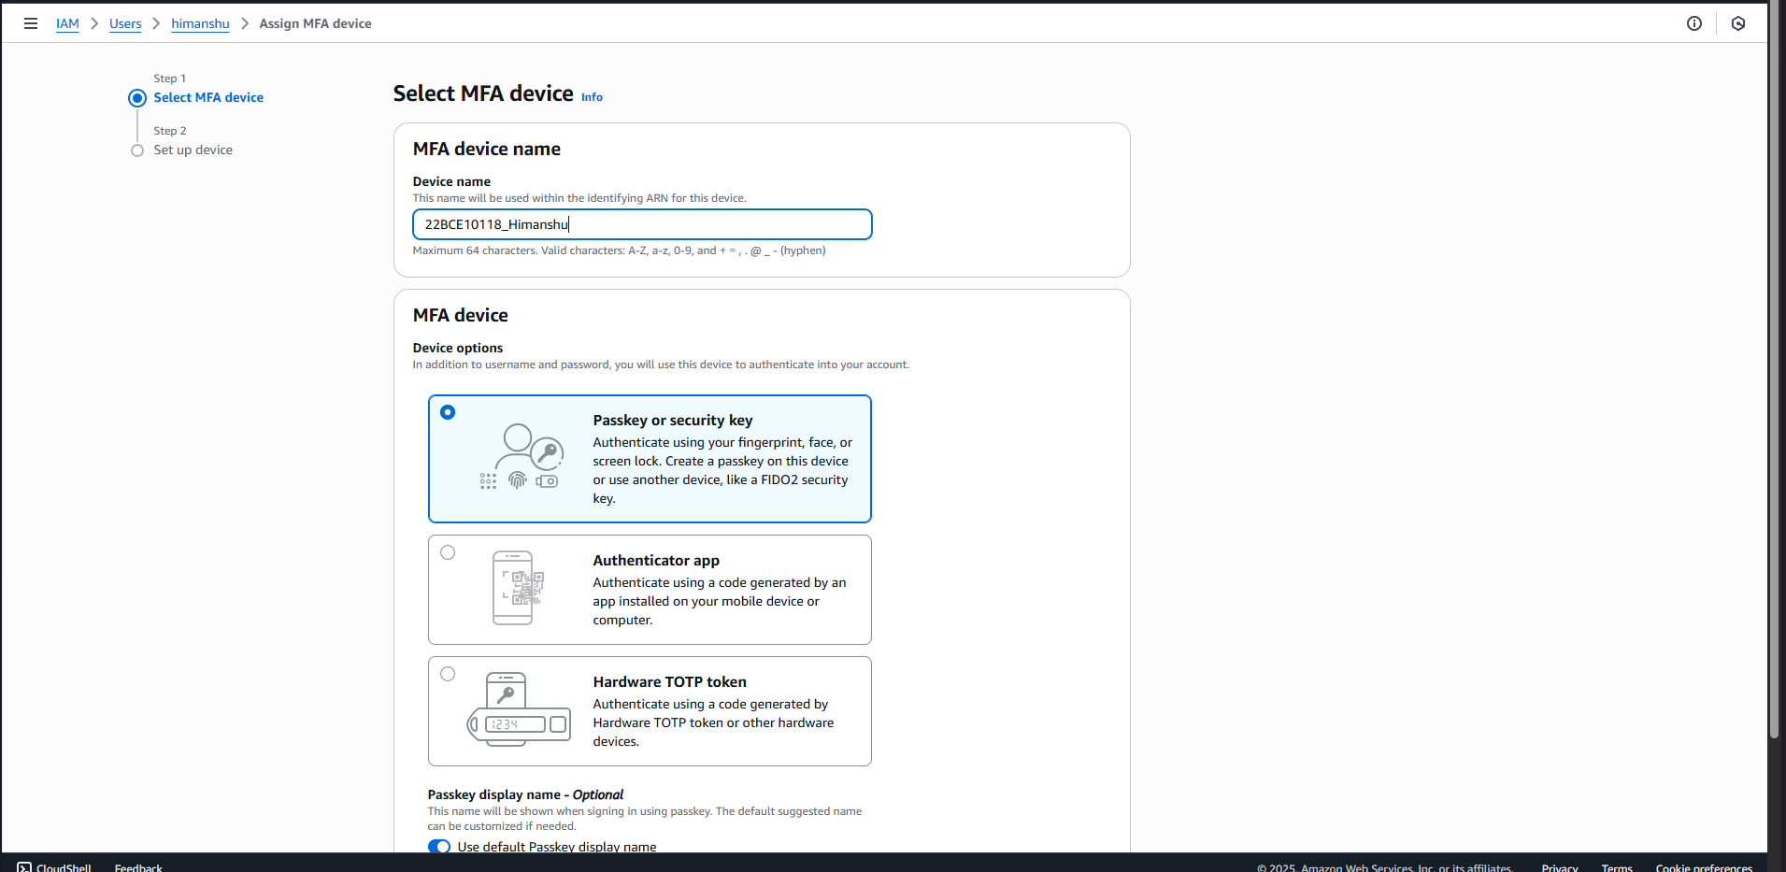

1. **Passkey MFA device assigned** successfully assigned .

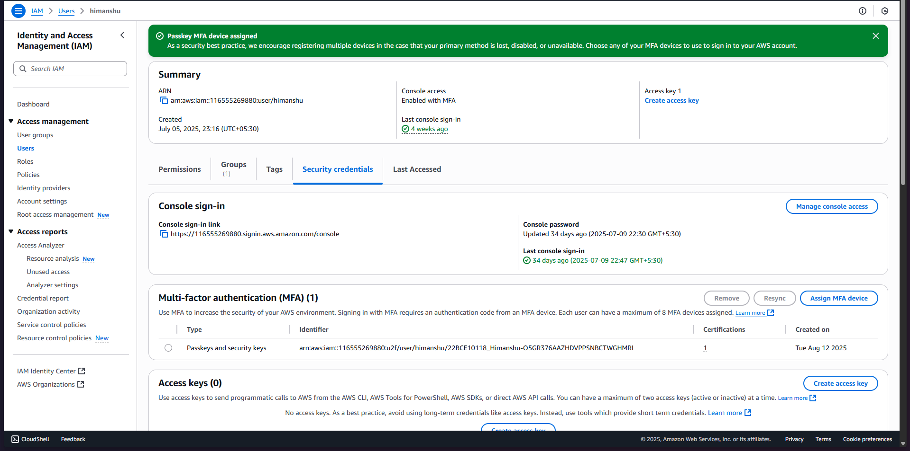

1. Now go on policies in the left pane and click on create policy .

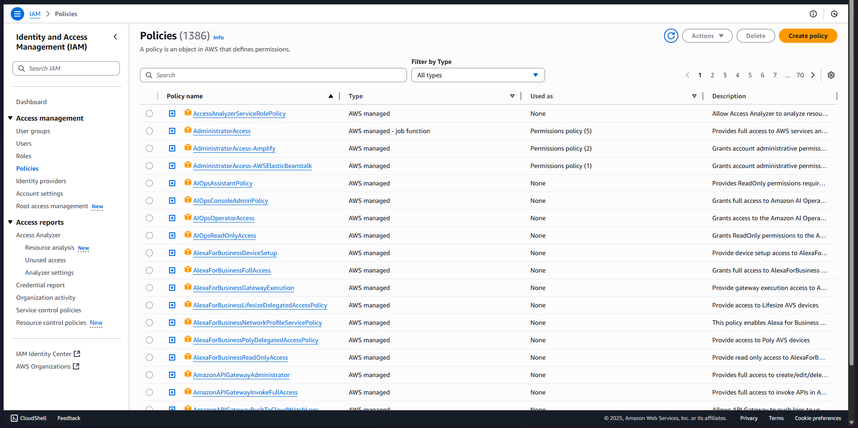

1. Then click on json and fill in the following code :

{

"Version": "2012-10-17",

"Statement": [

{

"Sid": "AllowAllActionsForMFAAuthenticatedUsers",

"Effect": "Deny",

"NotAction": [

"iam:CreateVirtualMFADevice",

"iam:EnableMFADevice",

"iam:GetUser",

"iam:ListMFADevices",

"iam:ListUsers",

"iam:ListVirtualMFADevices"

],

"Resource": "*",

"Condition": {

"BoolIfExists": {

"aws:MultiFactorAuthPresent": "false"

}

}

}

]

}

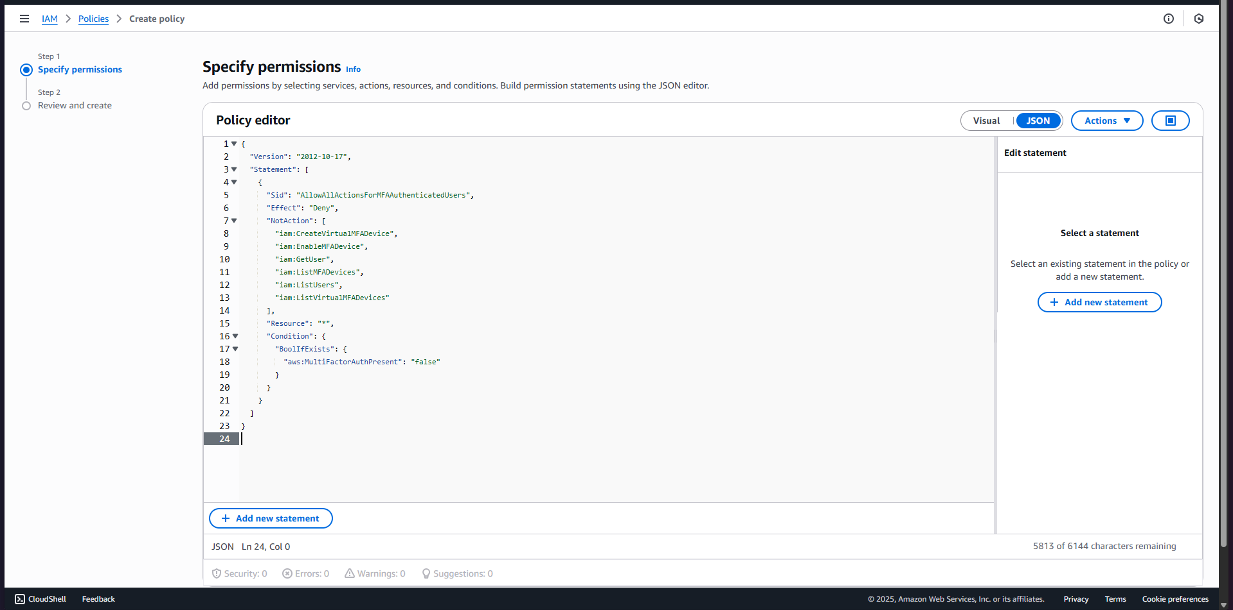

1. Name it , review it and create .

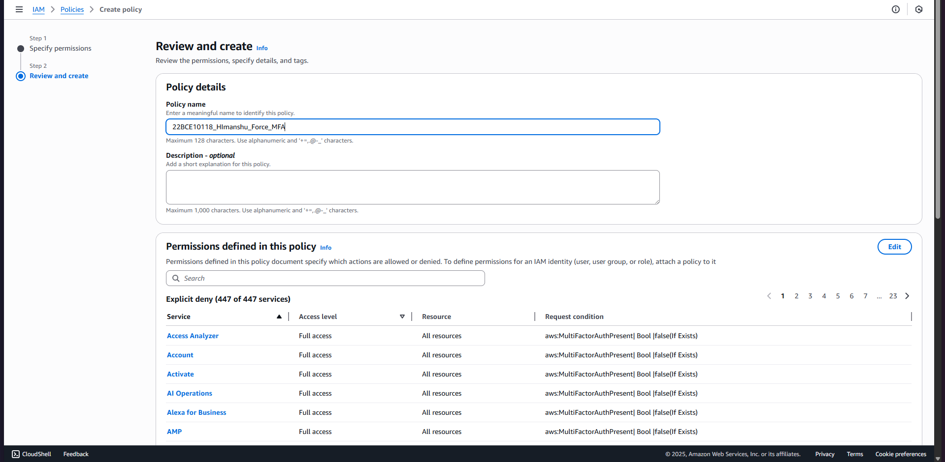

1. Policy successfully created .

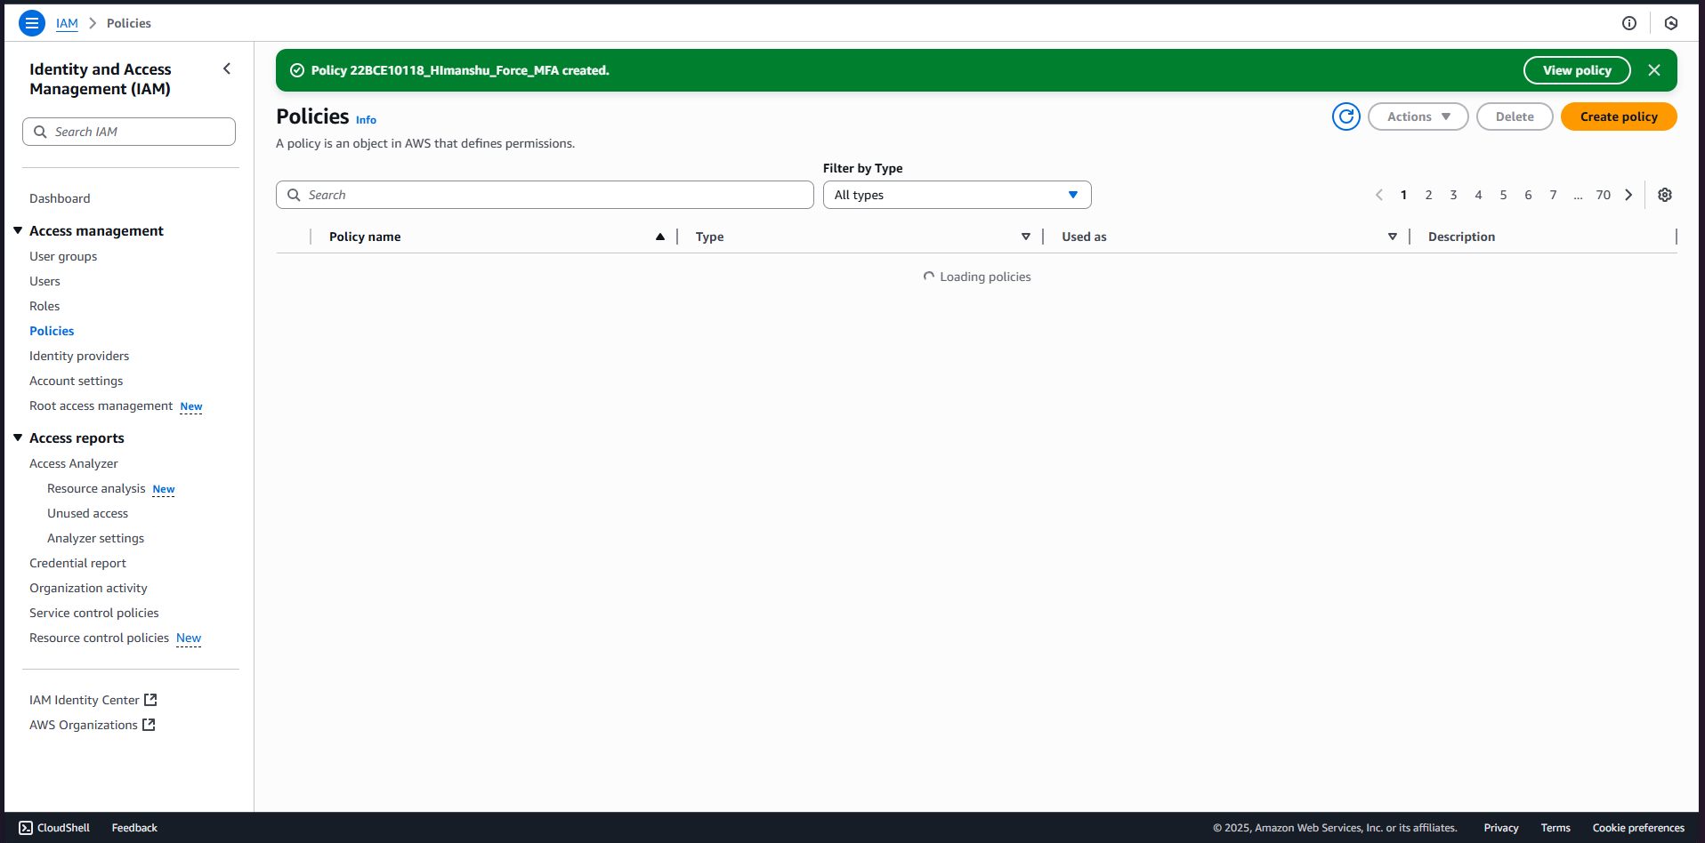

1. Now go on Himanshu user and click on add permissions then celect attach policies directly and choose the 22BCE10118_Himanshu_Force_MFA Policy and click on add permissions .

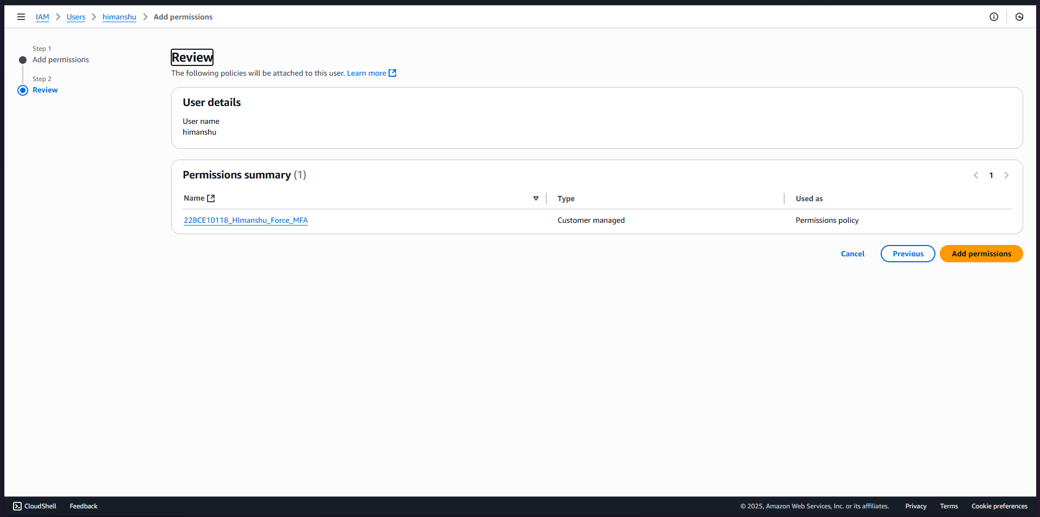

1. Policy successfully attached .

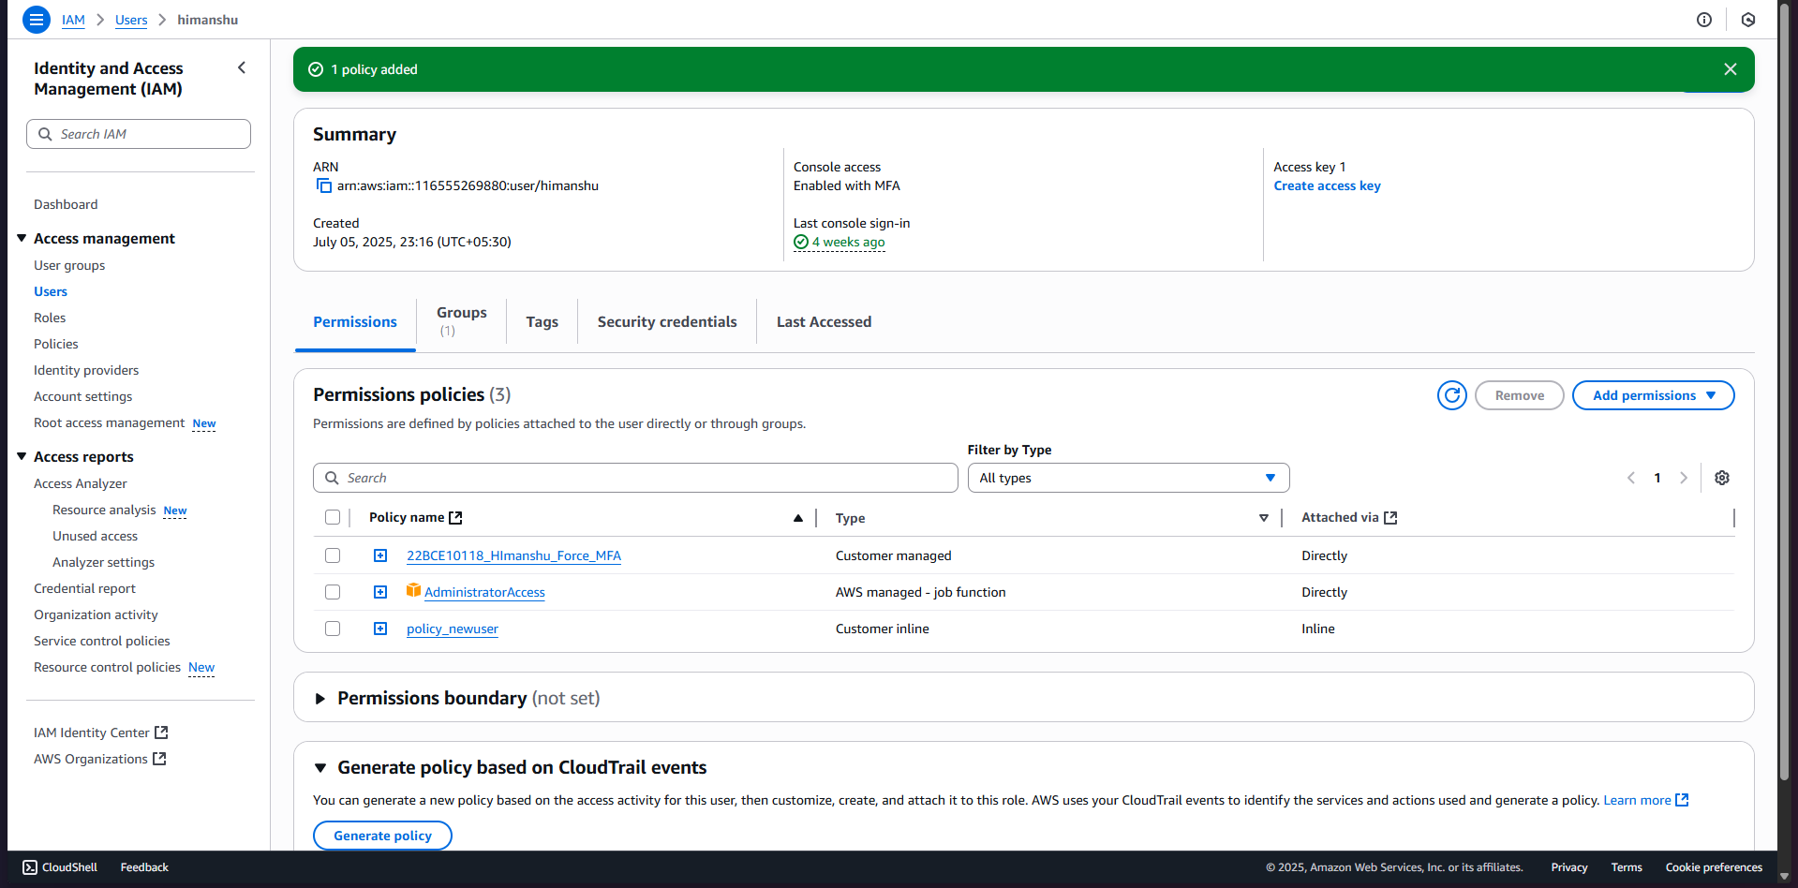

1. Use AWS CloudTrail to monitor and validate MFA enforcement by checking for sign-in events that include MFA authentication.

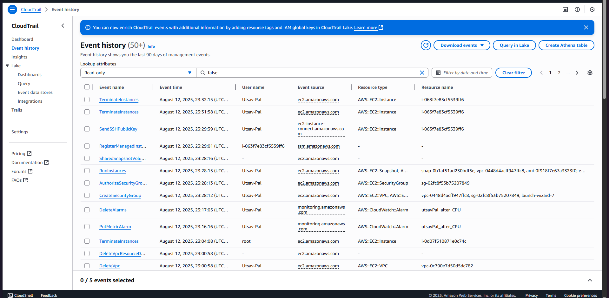

1. Analyze CloudTrail logs/event history to detect any attempts to bypass or disable MFA.
2. Now lets create an sns topic for alerts . Go to amazom SNS .

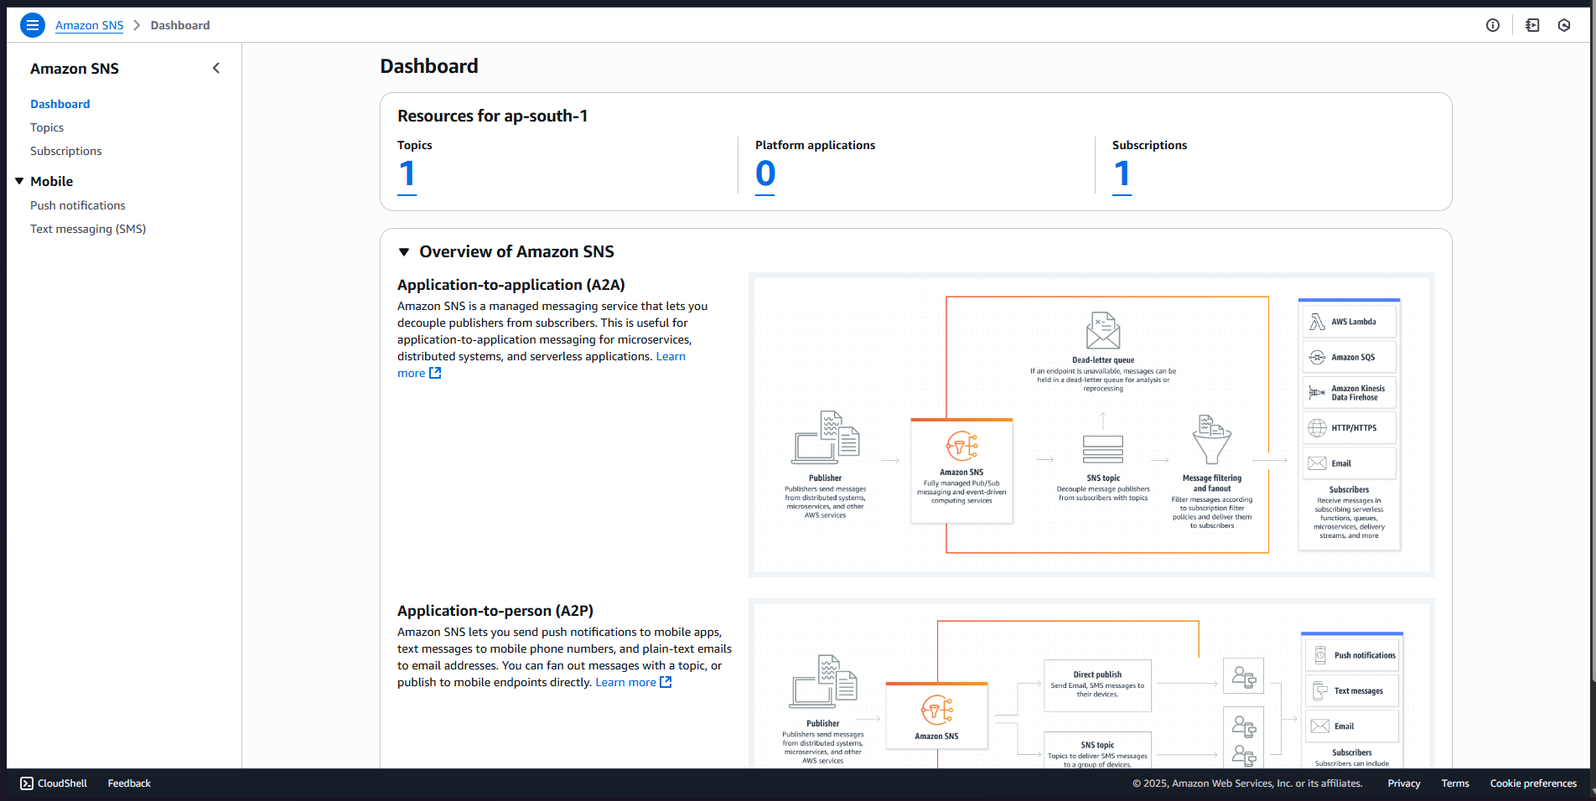

1. Now in topics click on create topic.

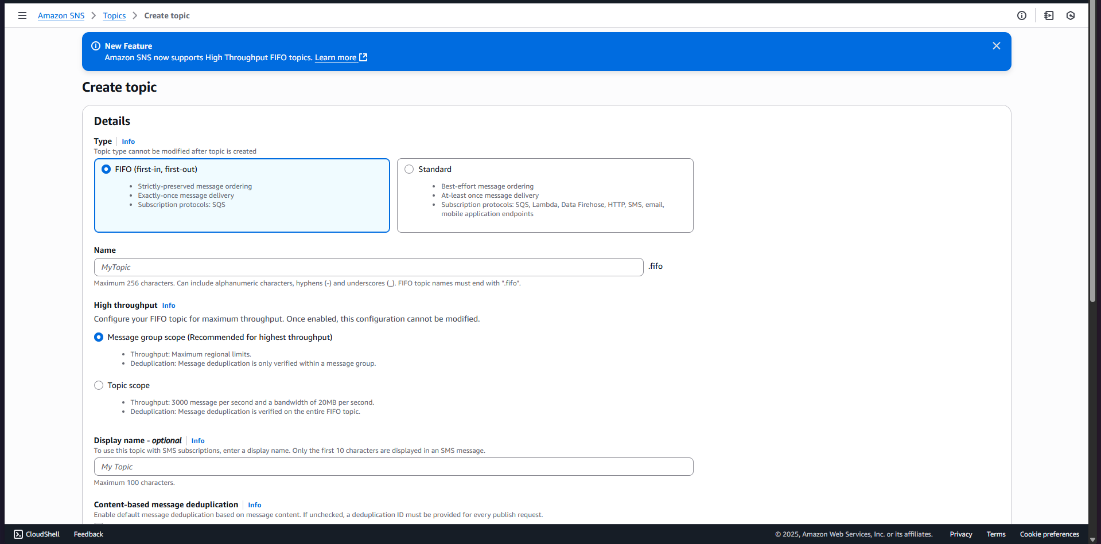

1. Fill in the names and click on create .

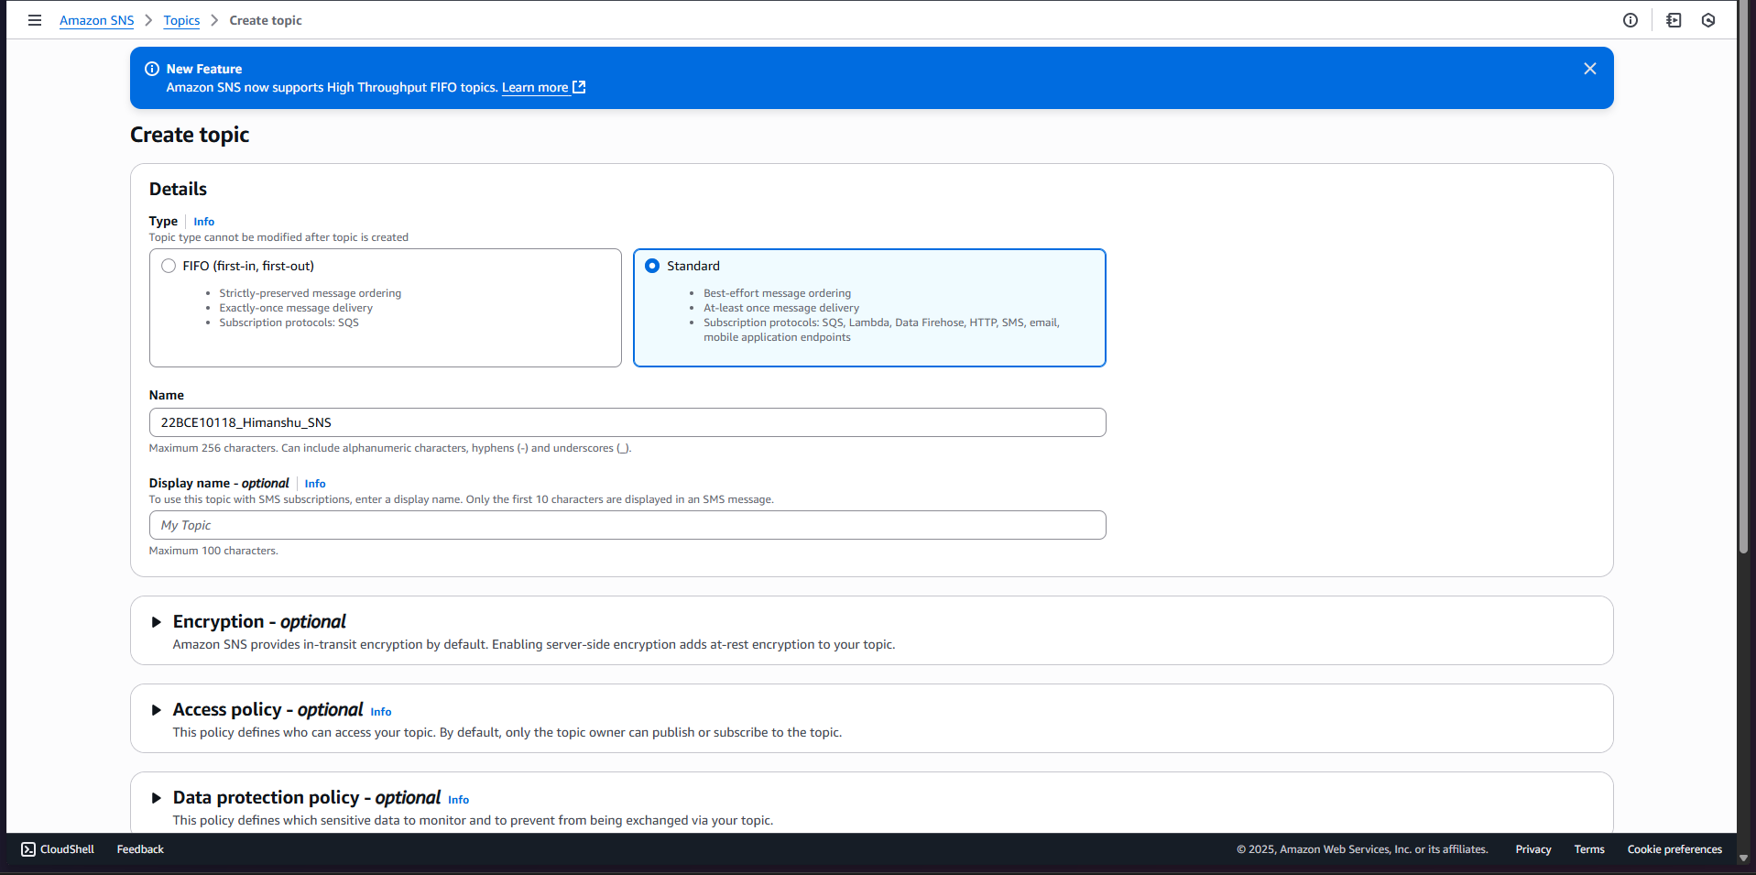

1. Topic successfully created .

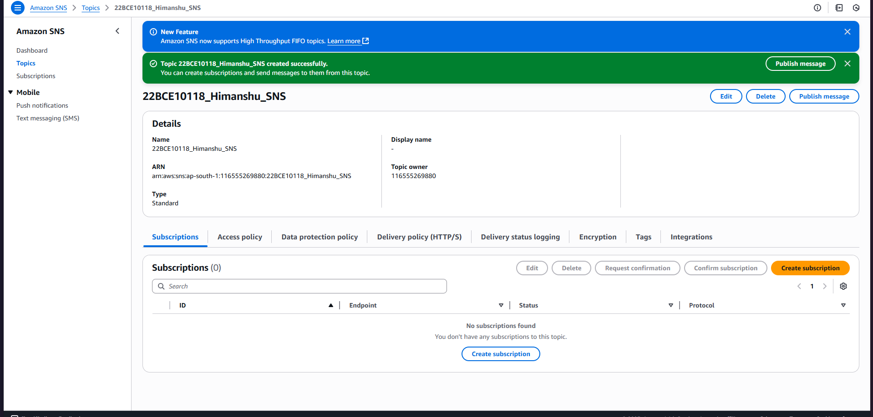

1. Now lets create a subscription . Click on create subscription.

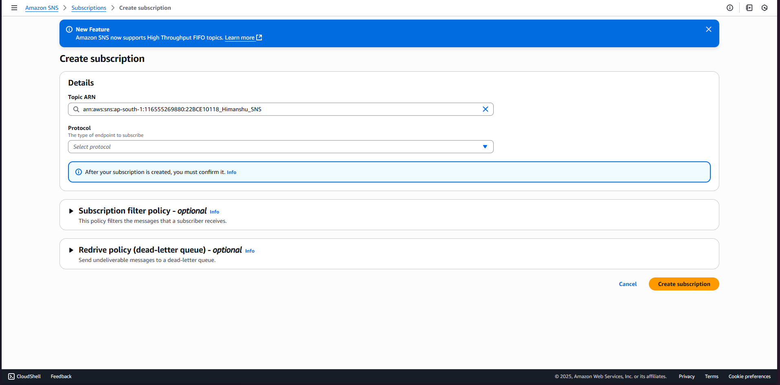

1. In the protocol select email and enter your email , then click on create subscription.

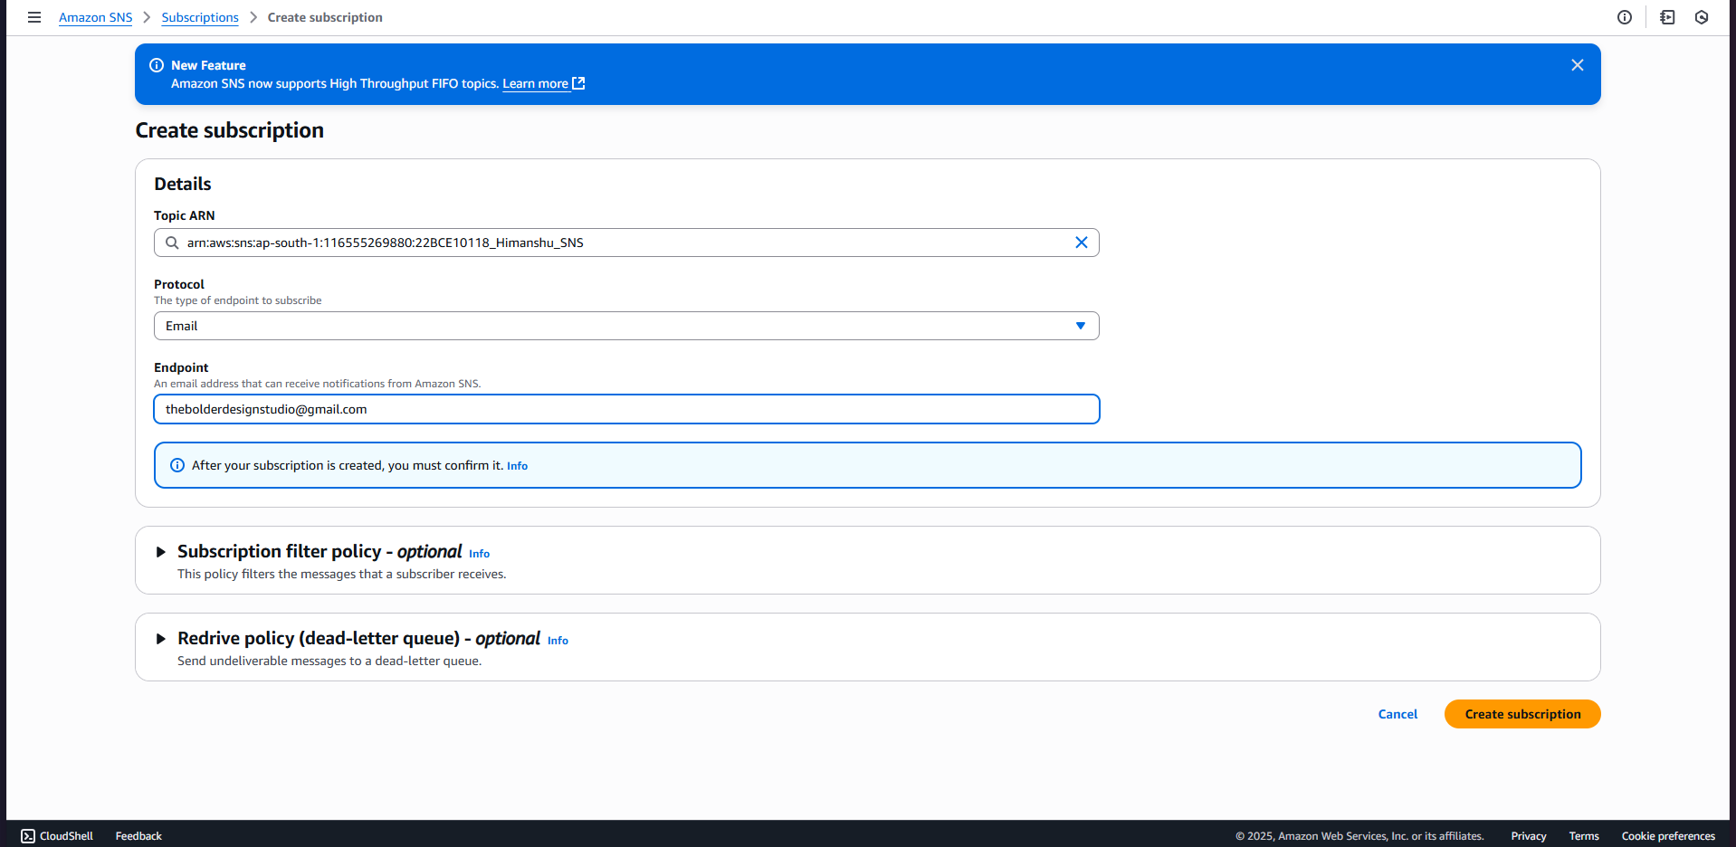

1. SNS subscription successfully created .

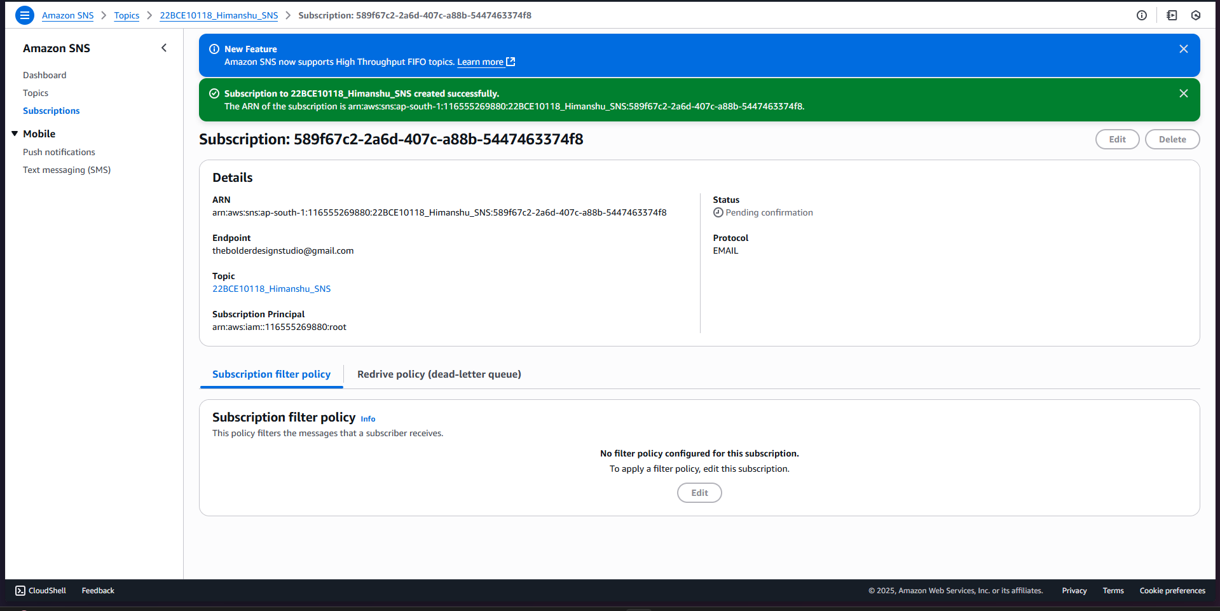

1. Now further , go in amazon eventbridge and click on create rule .

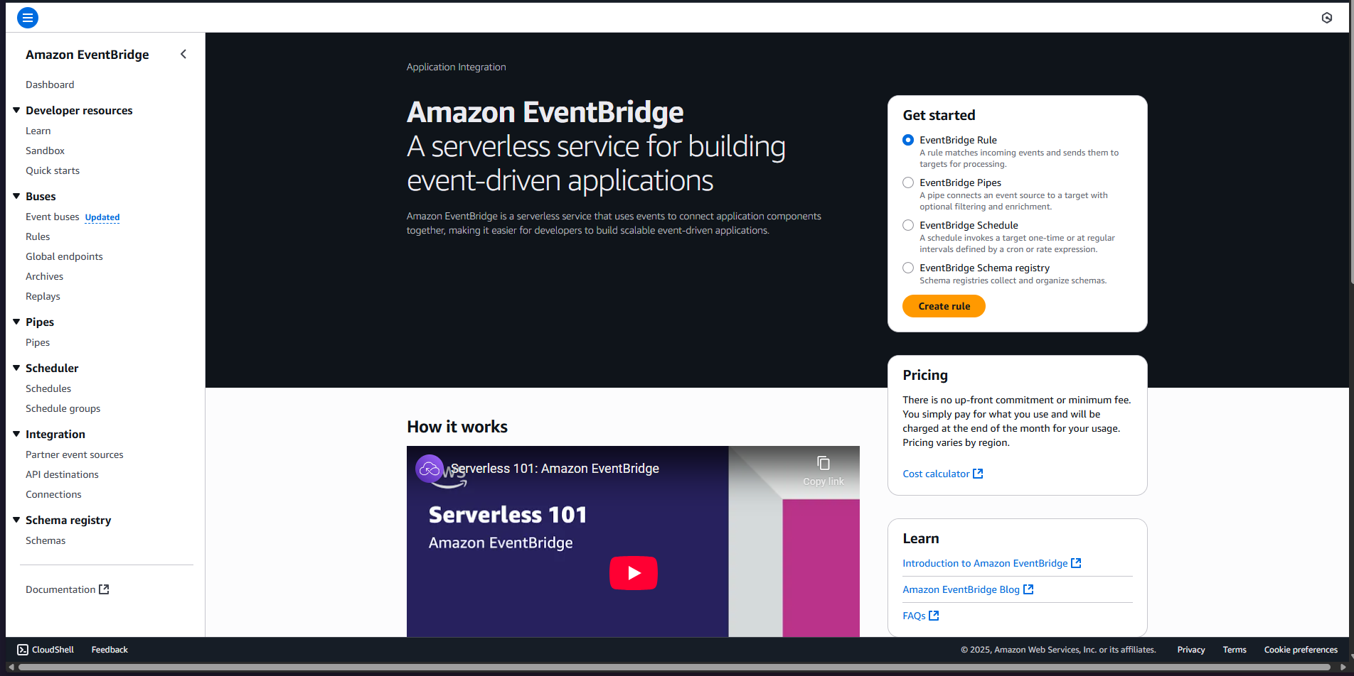

1. Fill in required details .

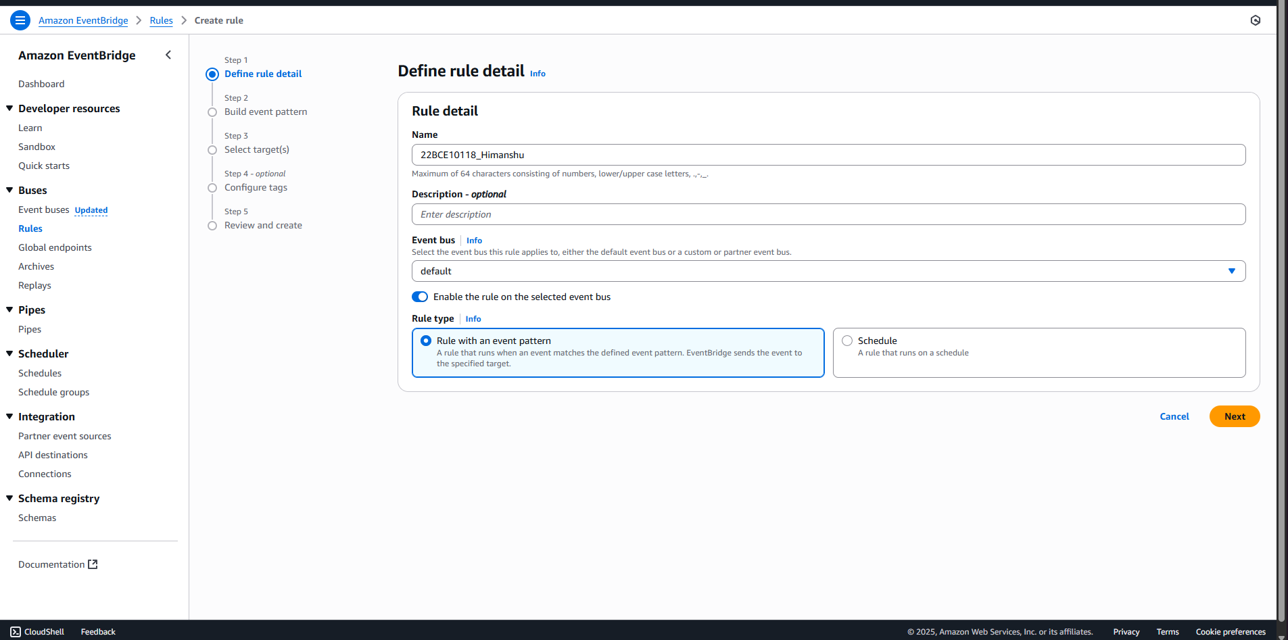

1. Now in the event pattern editor (json) enter below provided code .

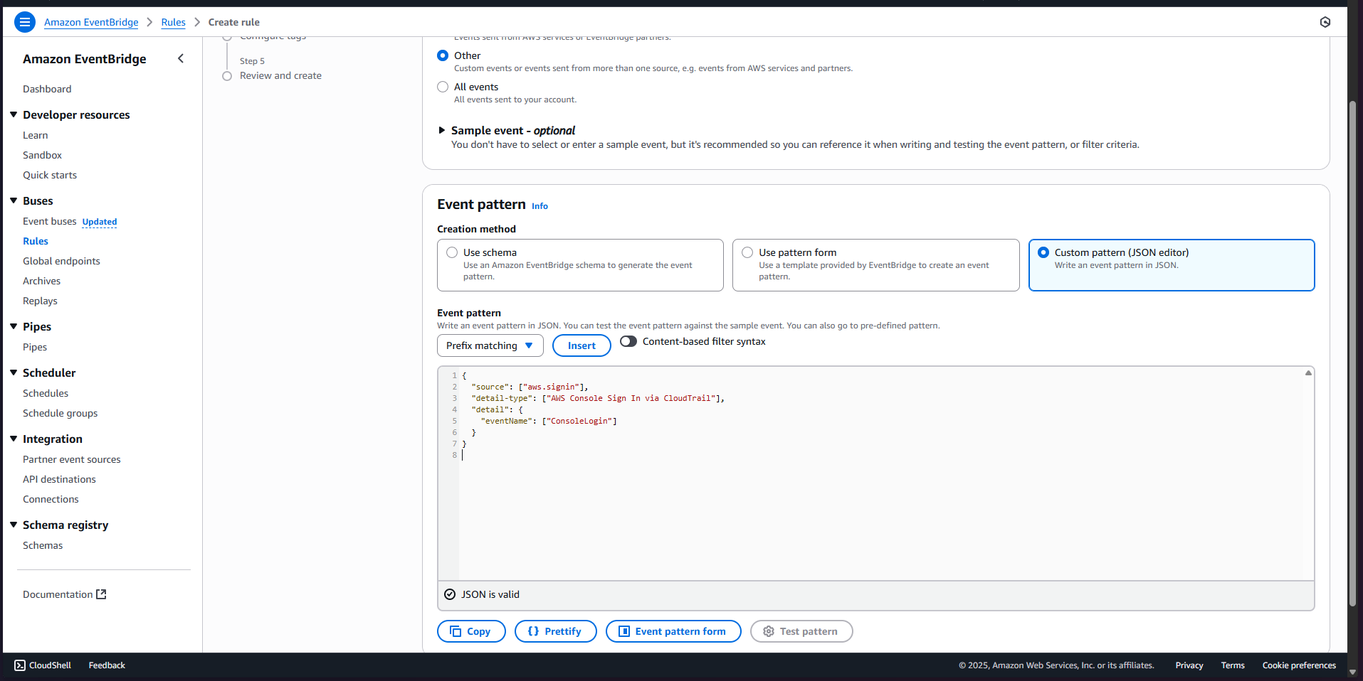

1. For targets, select “SNS topic” and choose the topic you’ve created for login alerts.

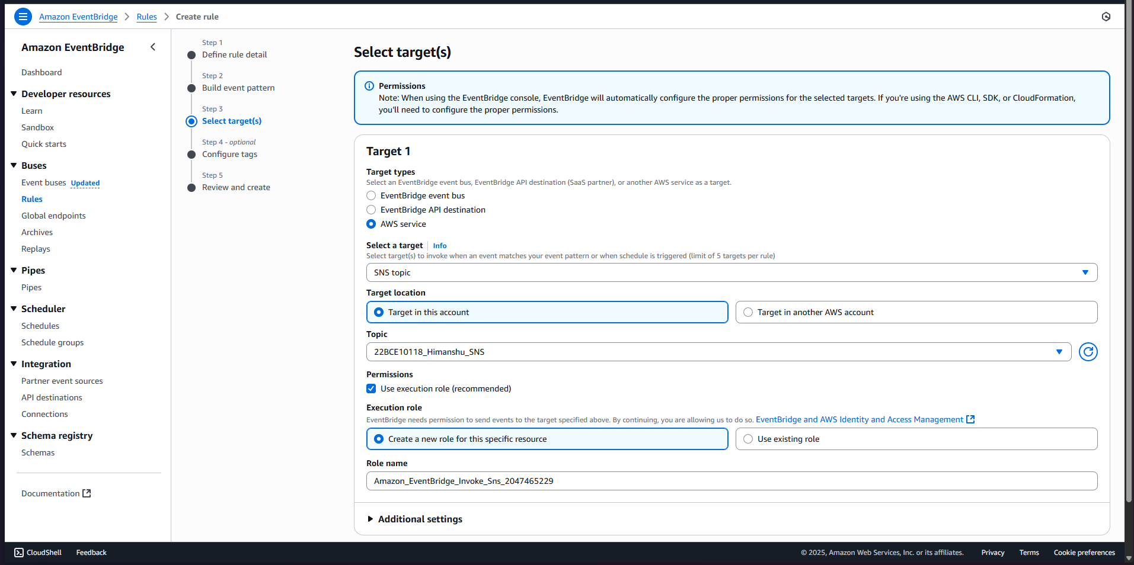

1. Rule successfully created .

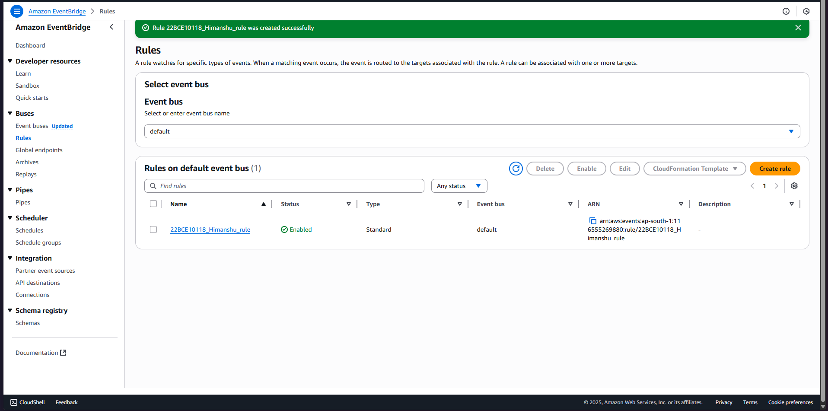

1. We have successfully created all required items and our account is secure and it would send an email through sns to our email address if a breakthrough is attempted.